How many species are there on Earth?

What is biodiversity?
The word ‘biodiversity’ was first used in the 1980s by American biologist EO Wilson. It is a conflation of ‘biological diversity’, and can be used to describe species, ecosystem, and genetic diversity. Biodiversity has historically been used to describe the range of organisms found on Earth, although the term species diversity is more specific, and incorporates measurements of both species richness (species number) as well as the relative abundances of each species in an area. The components of biodiversity are not independent – all ultimately are the consequence of genetic diversity interacting with environmental conditions to produce differences between organisms.
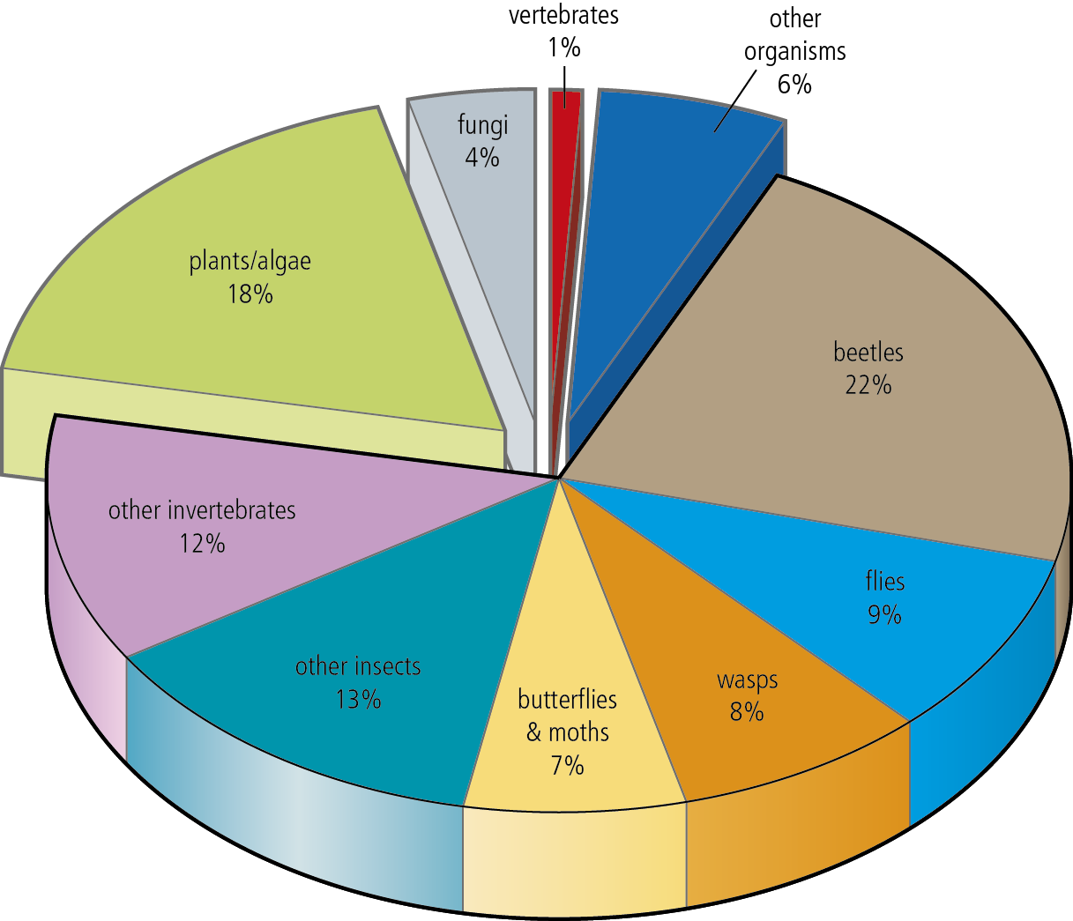
Figure 1 Described species divided into major groups. Of the 1.8 million described species,
over three-quarters are invertebrates.

How many species are there?
It is said that more is known about the surface of the moon than the deep ocean. This can be extrapolated to the whole of biology, where much remains still to be discovered. Humanity cannot answer many basic questions about life on Earth, including how many species there are on the planet. We know that there are approximately 1.8 million described species, but can only estimate how many other organisms remain undiscovered. Difficult-to-reach areas, such as the canopy of tropical rainforest, may harbour half of all species on Earth, but very little is known about them. The debate about how many species there are on Earth flourished in the 1980s and 1990s, and originated in a seemingly innocuous scientific paper written by American entomologist Terry Erwin, who estimated that there could be 30 million arthropods on Earth.
Since then, the need to understand more about the range and diversity of life has become increasingly pressing. Estimations of species extinction rates need to be framed in the light of known species numbers, so that a percentage loss of different groups can be calculated. Other reasons are equally as important.

Convention on biological diversity
Prior to the 1992 UN Rio Conference, a convention was developed to protect the Earth’s biodiversity (Convention on Biological Diversity – CBD). The CBD came into force in December 1993.
Questions
1 Why is the study of biodiversity of current concern? [5 marks]
2 What are the current estimates for the number of species on Earth? [1 mark]
3 Why are the numbers of species on Earth so poorly understood? [3 marks]
4 Explain how species diversity for an area may be calculated. [4 marks]
5 What are the objectives of the CBD? [2 marks]
6 How many countries have signed up to the CBD? [1 mark]
7 What is the Alliance for Zero Extinction? [3 marks]

Activity
Produce a display outlining what we currently know about global biodiversity. Use your answers to the above questions to help you. You should cover the following points:
- The current status of our understanding of the number of species on Earth
- How biodiversity is studied
- Areas of the world where biodiversity is especially poorly known, and why
- Conservation efforts to protect biodiversity
What does the future hold for biodiversity?

You may complete this using any media format you choose.
Answers
1 Habitat and ecosystem loss from human activity leading to species extinction; disappearance of
species with potential economic and agricultural value; loss of medical cures not yet discovered;
loss of Earth’s genetic diversity; threat to global climate and environment; ‘variety is the spice of life’ arguments. [5 max]
2 Range between 5–100 million: higher numbers may be possible if groups such as bacteria and
soil organisms are included, which are currently poorly understood. [1 mark]
3 Bias in the past towards large popular and appealing groups such as mammals and birds, which actually
represent a very small proportion of total species numbers; only a relatively small number of
taxonomists globally are involved in identifying and describing new species; most described species are large and smaller species requiring microscopic examination are less well known/historically less appealing for study; description of new species is laborious and archaic – modern techniques such as DNA technology and genome identification may prove a quicker and more accurate means of naming new species; some ecosystems remain poorly sampled, such as the canopy of rainforest and the deep sea. [3 max]
4 Transect/quadrat/sampling method to collect data on number and abundance of species; specific
examples of sampling methods given e.g. flight intercept trap, pitfall trap etc., Simpson’s/a diversity
index is used to calculate (species) diversity; then values are extrapolated for larger areas. [4 max]
5 An international treaty to sustain the rich diversity of life on Earth; the conservation of biological
diversity; the sustainable use of the components of biodiversity; the fair and equitable sharing of the benefits arising from genetic resources. [2 max]
6 192 states and the European Union. [1 mark]
7 A global initiative comprised of conservation organizations aiming to prevent extinctions; prevent
extinctions by identifying and safeguarding key sites where species are in imminent danger of
disappearing; the goal of the Alliance is to eliminate threats and restore habitats to allow
endangered species’ populations to recover. [3 marks]
Total: [19 marks]

