Taxonomy, Classification, and Dichotomous Keys
Help! Scientists have discovered quite a few new creatures on planet Pamishan. They need your help to identify and classify them. Use the dichotomous key on the next page to identify these creatures.
1. 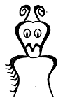 | 2. 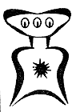 | 3. 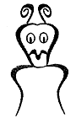 | 4. 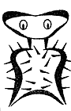 | 5. 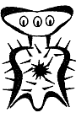
6. 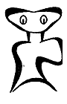 | 7. 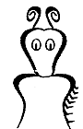 | 8. 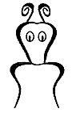 | 9. 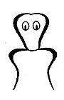 | 10. 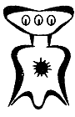
11. 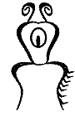 | 12. 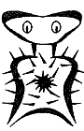 | 13. 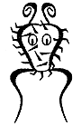 | 14. 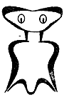 | 15. 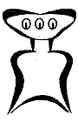
16. 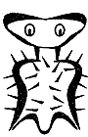 | 17. 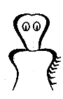 | 18. 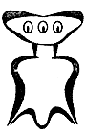 | 19. 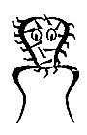 | 20. 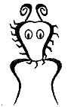

A Key to New Pamishan Creatures
1. |  | a. The creature has a large wide head............................go to 2
 |  | b. The creature has a small narrow head........................go to 11
2. |  | a. It has 3 eyes ...............................................................go to 3
 |  | b. It has 2 eyes ...............................................................go to 7
3. |  | a. There is a star in the middle of its chest......................go to 4
 |  | b. There is no star in the middle of its chest ...................go to 6
4. |  | a. The creature has hair spikes ......................................Broadus hairus
 |  | b. The creature has no hair spikes..................................go to 5
5. |  | a. The bottom of the creature is arch-shaped ................Broadus archus
 |  | b. The bottom of the creature is M-shaped ....................Broadus emmus
6. |  | a. The creature has an arch-shaped bottom ..................Broadus plainus
 |  | b. The creature has an M-shaped bottom.......................Broadus tritops
7. |  | a. The creature has hairy spikes ....................................go to 8
 |  | b. The creature has no spikes........................................go to 10
8. |  | a. There is a star in the middle of its body ....................Broadus hairystarus
 |  | b. The is no star in the middle of its body .....................go to 9
9. |  | a. The creature has an arch shaped bottom ................Broadus hairyemmus
 |  | b. The creature has an M shaped bottum ....................Broadus kiferus
10. |  | a. The body is symmetrical .........................................Broadus walter
 |  | b. The body is not symmetrical....................................Broadus anderson
11. |  | a. The creatrue has no antennae ................................go to 12
 |  | b. The creature has antennae .....................................go to 14
12. |  | a. There are spikes on the face ..................................Narrowus wolfus
 |  | b. There are no spikes on the face .............................go to 13
13. |  | a. The creature has no spike anywhere ..........................Narrowus blankus
 |  | b. There are spikes on the right leg .................................Narrowus starboardus
14. |  | a. The creature has 2 eyes...............................................go to 15
 |  | b. The creature has 1 eye................................................Narrowus cyclops
15. |  | a. The creature has a mouth............................................go to 16
 |  | b. The creature has no mouth..........................................go to 17
16. |  | a. There are spikes on the left leg ..................................Narrowus portus
 |  | b. There are no spikes at all ...........................................Narrowus plainus
17. |  | a. The creature has spikes .............................................go to 18
 |  | b. The creature has no spikes ........................................Narrowus georginia
18. |  | a. There are spikes on the head .....................................go to 19
 |  | b. There are spikes on the right leg.................................Narrowus montanian
19. |  | a. There are spikes covering the face .............................Narrowus beardus
 |  | b. There are spikes only on the outside edge of head......Narrowus fuzzus
Creature No. | Name | Creature No. | Name
1 |  | 11
2 |  | 12
3 |  | 13
4 |  | 14
5 |  | 15
6 |  | 16
7 |  | 17
8 |  | 18
9 |  | 19
10 |  | 20

