Interactions of the Community
- Outline six factors that affect the distribution of plant species.
Temperature | Soil pH | Light
Enzyme-controlled reactions occur at optimal temperatures and some plants show extreme adaptations, such as frost-resistant crops and Manzanita shrubs, which need fire for germination.
Water | Salinity | Mineral nutrients

- Explain how the following factors affect the distribution of animal species:
Factor | Effect on the distribution of animals
Temperature
Water
Food Supply
Breeding sites
Territory

- Explain the following interactions between species, giving two examples of each:
Herbivory | Explain:
 | e.g. 1: | e.g.2:
Predation | Explain:
 | e.g. 1: | e.g.2:
Intra-specific competition | Explain:
 | e.g. 1: | e.g.2:
Inter-specific competition | Explain:
 | e.g. 1: | e.g.2:
Parasitism | Explain:
 | e.g. 1: | e.g.2:
Mutualism | Explain:
 | e.g. 1: | e.g.2:

- Explain what is meant by the niche concept.

- Give an example of two species in their niches:

Example 1: | Amphiprion ocellaris (clownfish)
Habitat:
Nutrition:
Interactions:
Predators:
Reproduction:
Other information:

Example 1:
Habitat:
Nutrition:
Interactions:
Predators:
Reproduction:
Other information:

- Distinguish between fundamental and realized niches.
Fundamental:

Realised:

- Using examples, explain the consequences of environmental change on a species with :
A narrow niche: | A broad niche:

- Outline the method and importance of GF Gause’s paramecium experiments. (http://www.ggause.com/gfg05.htm)
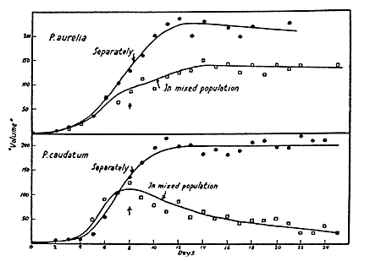
- Explain the competitive exclusion principle.

- Using examples, explain how competitive exclusion can lead to:
  - The removal/ replacement of one species from a niche.

