Topic 2 The Ecosystem

1. Define the following terms:

*Species: A group of organisms that can interbreed to produce fertile offspring.*

*Habitat*

*Population*

*Community*

*Ecosystem*

*Ecology*

*Niche*

*Biodiversity*

*Trophic level*

1. Complete the tree below with definitions and examples of each type of feeding strategy.

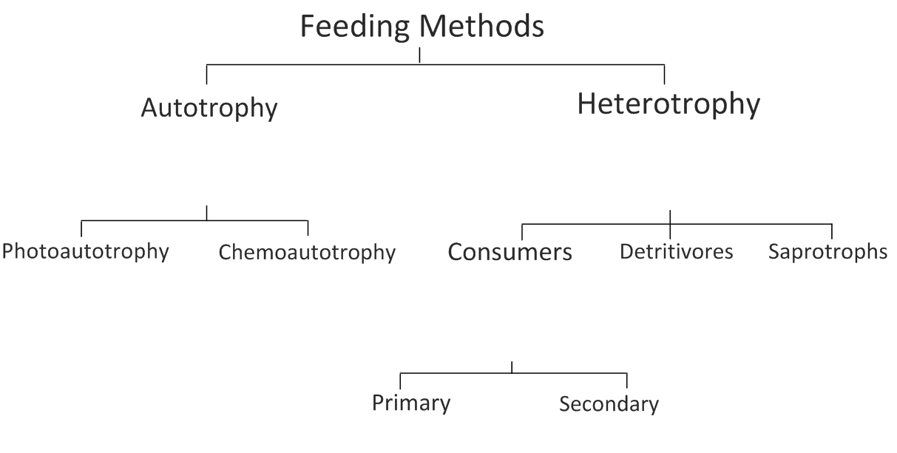Distinguish between the feeding strategies at each level of the diagram.

1. **Food chains** represent the flow of energy and nutrients in a series of feeding relationships.

Give one example of a **marine** food chain (min. 4 organisms)

Give one example of a **terrestria**l food chain (min. 4 organisms)

Give one other example of a food chain (min. 4 organisms)

1. Describe what is meant by a food web.
2. The food web below shows some coral reef feeding relationships;

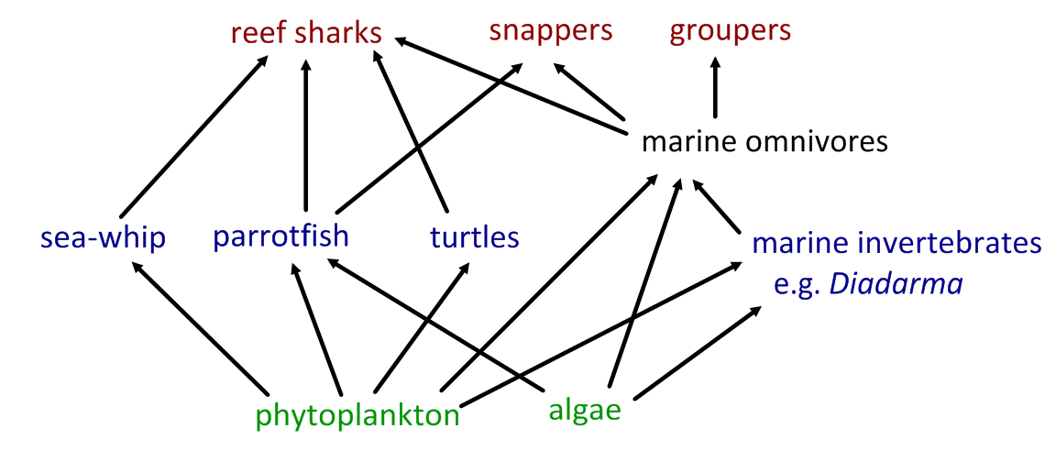

1. Identify species in the following trophic levels:
2. Producers
3. Primary consumers
4. Secondary consumers
5. On a separate sheet, construct a freshwater food web based on the following information:

|  |  |
| --- | --- |
| **Organism** | **Energy sources** |
| Water crowfoot | Sunlight |
| Cased caddisfly larva | Micro-plants, algae, particles of dead plants and animals |
| Damselfly nymph | Micro-plants, algae, particles of dead plants and animals |
| Mayfly nymph | Micro-plants, algae, particles of dead plants and animals |
| Dragonfly | Other adult insects and small flies |
| Duck | All nymphs, all plants, snails, tadpoles, young frogs |
| Freshwater Shrimp | Particles of dead plants and animals |
| Water vole | Plants |
| Algae | Sunlight |
| Otter | Fish, frogs and newts |
| Water starwort | Sunlight |
| Pond snail | Microplants, all water plants and algae |
| Alderfly nymph | Micro-plants, algae, particles of dead plants and animals |
| Pond skater | Particles of dead plants and animals |
| Frog | Mayfly, midge larvae, pond skater, caddisfly, small flies |
| Tadpole | Micro-plants, algae |
| Micro-plants | Sunlight |
| Great diving beetle | Water flea, snails, tadpole, all nymphs |
| Bullhead fish | Diving beetle, tadpole, all nymphs, water flea, snail, midge larvae |

*Adapted from:* [*http://www.cornwallriversproject.org.uk/education/education_pack.htm*](http://www.cornwallriversproject.org.uk/education/education_pack.htm)

1. For the food web created above:
2. Identify organisms in each of the trophic levels.
3. Identify organisms that fit more than one trophic level.
4. Identify those which could be classed as detritivores
5. Suggest why it is sometimes difficult to classify organisms into trophic levels.
6. Outline why numbers of organisms are smaller at higher trophic levels.
7. State the original source of energy for almost all communities.
8. Explain how energy flows through a community, including why energy transfers are never 100% efficient.
9. State the function of a pyramid of energy.
10. Give an example of a unit of measurement used in a pyramid of energy, giving a description of each component.
11. “*Energy flows through an ecosystem, nutrients are recycled*.”

Explain this statement with the aid of a flow chart. Include the roles of saprotrophic bacteria and fungi.

1. Outline three examples of cycles of inorganic nutrients. For each, outline the uses of the nutrients in living organisms, its method of transfer into and through the food chain and how it is returned to the inorganic nutrient pool.
   1. Carbon
   2. Nitrogen
   3. Calcium