**Practical Ecology**

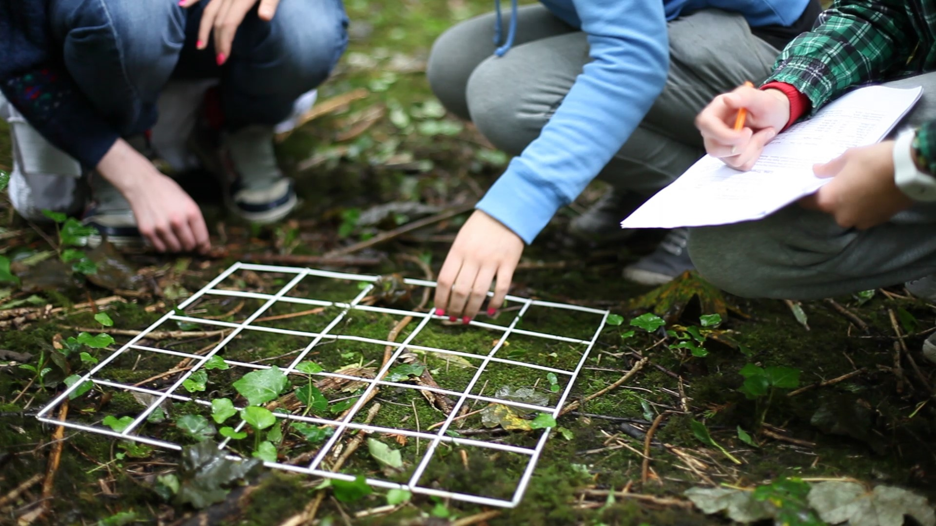

Student Workbook: **IB ESS**

**Name:** ____________________________________________________________

**INTRODUCTION TO SAMPLING**

Ecology is often referred to as the "study of distribution and abundance". This being true, we would often like to know how many of a certain organism are in a certain place, or at a certain time. Information on the abundance of an organism or group of organisms is fundamental to most questions in ecology. However, we can rarely do a complete census of the organisms in the area of interest because of limitations to time or research funds. Therefore, we usually have to **estimate** the abundance of organisms by **sampling** them or counting a subset of the population of interest.

For example, suppose you wanted to know how many ants there were in the Rama IV park. It

would take a lifetime to count them all, but you could estimate their abundance by counting all the ants in

carefully chosen smaller areas throughout the park.

**RANDOM SAMPLING USING QUADRATS**

Random sampling is usually carried out when the area under study is fairly uniform, very large, and or there is limited time available. When using random sampling techniques, large numbers of samples/records are taken from different positions within the habitat. A quadrat is most often used for this type of sampling. The frame is placed on the ground and the animals, and/ or plants inside it are counted. This is done many times at different points within the habitat to give a large number of different samples.

A better method of random sampling is to map/mark out your area to be sampled with tape or rope. Using a pair of random numbers you can locate a position within the sampling area to collect your data. The random numbers can be pulled from a set of numbers in a hat, come from random number tables, or be generated by a calculator or computer. The two numbers are used as coordinates to locate a sampling position within the area. The first random number gives the position on the first tape and the second random number gives the position on the second tape.



**Fig 1 Finding a random area**

**USING A QUADRAT TO MEASURE ABUNDANCE OF A SPECIES**

The usual sampling unit is a quadrat. Quadrats normally consist of a square frame, the most frequently used size being 0.25m2 (see picture below). The purpose of using a quadrat is to enable comparable samples to be obtained from areas of consistent size and shape.

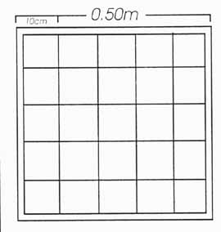Each square within this quadrat represents 4% of the quadrat.

**IN**

Decide which borders are going to count as ‘in’ and which will count as ‘out’.

Any organisms that fall on the lines deemed as being ‘out’ should not be counted.  
**MEASURING DENSITY OF A SPECIES: RANDOM SAMPLING – we can model this in the lab or go outside**

**OUT**

**OUT**

**IN**

1. Calculate the area of your quadrat *(show your working below)*

area = ………………………….m2

1. Name the species you will be investigating: ………………………….
2. Mark off the area to be sampled using chalk, tape etc. It is recommended that the smallest area to be sampled is 25m x 25m
3. Use a random number generator to generate 10 sets of coordinates. <https://www.random.org/> These coordinates will tell you where to place your quadrat. You can do this by picking numbers out of a hat.

12

10

0

Area to be sampled marked off

|  |  |
| --- | --- |
| **1st random number** | **2nd Random number** |
| **2** | **10** |
| **6** | **1** |
| **0** | **2** |
| **1** | **8** |
| **4** | **6** |

Bottom left hand corner of quadrat laid down where two numbers intersect

0 2 10

1. Count the number of individuals (coloured beads) in your quadrat – remember to use the ‘in’ and ‘out’ rule!

|  |  |
| --- | --- |
| **Quadrat number** | **Number of individuals** |
| 1 |  |
| 2 |  |
| 3 |  |
| 4 |  |
| 5 |  |

1. Calculate the mean number of individuals per quadrat

…………………………. per …………………………. m2

*(this is the area of your quadrat)*

1. Now calculate how many quadrat areas would fit into your sample area:

………………………….

1. Multiply by your answer for mean number of individuals by your answer for 5.b) This will give you an estimated number of individuals in your whole sample area.

…………………………. in …………………………. m2

1. Now complete your data processing by calculating how many individuals are found per m2

(*divide the first part of your answer to question 6 by the second part of your answer to question 6)*

…………………………. per m2

**MEASURING PERCENTAGE (%) COVER OF A SPECIES**

In many plant species e.g. grasses it is very difficult to count the number of individual plants so calculating density is not possible. Count the number of squares **within** the quadrat that the species completely covers. Then count the squares that are only partially covered. Use this information to estimate the total number of squares that would be completely covered.

1. Calculate the percentage of each square in your quadrat *(100 ÷ no. of squares)*

Each square = ………………………….%

1. Name the species you will be investigating: ………………………….
2. Mark off the area to be sampled using chalk, tape etc. It is recommended that the smallest area to be sampled is 25m x 25m
3. Use a random number generator to generate 10 sets of coordinates. These coordinates will tell you where to place your quadrat. You can do this by picking numbers out of a hat.

12

10

0

Area to be sampled marked off

|  |  |
| --- | --- |
| **1st random number** | **2nd Random number** |
| 3 | 6 |
| 6 | 3 |
| 9 | 2 |
| 10 | 5 |
| 4 | 10 |

Bottom left hand corner of quadrat laid down where two numbers intersect

0 2 10

1. Count the number of squares **within** the quadrat that the species completely covers. Then count the squares that are only partially covered. Use this information to estimate the total number of squares that would be completely covered. Fill in the ‘Number of Squares column’

|  |  |  |  |
| --- | --- | --- | --- |
| **Quadrat number** | **Number of squares** | **Percentage cover (%)** | **ACFOR scale** |
| 1 |  |  |  |
| 2 |  |  |  |
| 3 |  |  |  |
| 4 |  |  |  |
| 5 |  |  |  |

1. Multiply the figure in the ‘Number of squares’ column by your answer to Q8. Write your answer in the ‘Percentage cover’ column. Repeat for all 10 quadrats.

The ACFOR Scale

ACFOR is an acronym for a simple, somewhat subjective scale used to describe species abundance within a given area. It is normally used within a sampling quadrat to indicate how many organisms there are in a particular habitat when it would not be practical to count them all.

The ACFOR scale is as follows:

**A = ABUNDANT (greater than / equal to 51%)**

**C = COMMON (26-50%)**

**F = FREQUENT (12-25%)**

**O = OCCASIONAL (6-11%)**

**R = RARE (6% to single individual)**

1. Use the information above to determine the abundance for each quadrat and write this into the ‘ACFOR Scale’ column.
2. Calculate the mean percentage cover per quadrat

…………………………. per …………………………. m2

*(this is the area of your quadrat)*

1. Now calculate how many quadrat areas would fit into your sample area *(sample ÷ area)*

………………………….

1. Multiply your answer for mean percentage cover by your answer for 15. This will give you an estimated mean percentage cover in your whole sample area.

…………………………. in …………………………. m2

1. Now complete your data processing by calculating percentage cover per m2

(*divide the first part of your answer to question 17 by the second part of your answer to question 17)*

…………………………. per m2

How would you describe the percentage cover per m2 based on the ACFOR scale?

………………………….………………………….

**MEASURING ABIOTIC FACTORS**

Measuring the abiotic factors in each sample site is very important. The abundance and diversity of species are dependent on the environmental conditions in an ecosystem.

**When sampling an ecosystem:**

Make 2 readings with each sensor at the **centre position** from the quadrat and at 2 different levels in **each quadrat**: ground level and 1 m height.

**Central position for sensors readings:**

**X**

**Abiotic factor reading positions in each quadrat**

|  |  |  |
| --- | --- | --- |
| **Abiotic factor** | **Reading at ground level (±unit)** | **Reading at 1m (±unit)** |
| Light intensity  (LUX) |  |  |
| Temperature  (oC) |  |  |

**MEASURING SPECIES DIVERSITY**

1. Identify three different species at your site. You don’t have to know their name. You can take a picture or draw them. For the purposes of this exercise, the 3 different types of species will be different coloured beads.

2. Mark off the area to be sampled.

3. Use a random number generator to generate 5 sets of coordinates. These coordinates will tell you where to place your quadrat. You can do this by picking numbers out of a hat.

25

18

0

Area to be sampled marked off

|  |  |
| --- | --- |
| **1st random number** | **2nd Random number** |
|  |  |
|  |  |
|  |  |
|  |  |
|  |  |

Bottom left hand corner of quadrat laid down where two numbers intersect

0 7 25

4. Count the number of individuals of each species in each quadrat.

|  |  |  |  |  |  |
| --- | --- | --- | --- | --- | --- |
| Number of individuals in each quadrat | | | | | |
| **Species** | **1** | **2** | **3** | **4** | **5** |
| **A** |  |  |  |  |  |
| **B** |  |  |  |  |  |
| **C** |  |  |  |  |  |

5. Calculate Simpson’s Diversity Index for each quadrat

**Quadrat 1:**

|  |  |  |
| --- | --- | --- |
| **Species** | **Number of Individuals (n)** | **n(n-1)** |
| **A** |  |  |
| **B** |  |  |
| **C** |  |  |
| **Total** |  |  |
|  | **N** | **Ʃn(n-1)** |



**Quadrat 2:**

|  |  |  |
| --- | --- | --- |
| **Species** | **Number of Individuals (n)** | **n(n-1)** |
| **A** |  |  |
| **B** |  |  |
| **C** |  |  |
| **Total** |  |  |
|  | **N** | **Ʃn(n-1)** |



**Quadrat 3:**

|  |  |  |
| --- | --- | --- |
| **Species** | **Number of Individuals (n)** | **n(n-1)** |
| **A** |  |  |
| **B** |  |  |
| **C** |  |  |
| **Total** |  |  |
|  | **N** | **Ʃn(n-1)** |



**Quadrat 4:**

|  |  |  |
| --- | --- | --- |
| **Species** | **Number of Individuals (n)** | **n(n-1)** |
| **A** |  |  |
| **B** |  |  |
| **C** |  |  |
| **Total** |  |  |
|  | **N** | **Ʃn(n-1)** |



**Quadrat 5:**

|  |  |  |
| --- | --- | --- |
| **Species** | **Number of Individuals (n)** | **n(n-1)** |
| **A** |  |  |
| **B** |  |  |
| **C** |  |  |
| **Total** |  |  |
|  | **N** | **Ʃn(n-1)** |



6. Calculate the mean Simpson’s Diversity Index for the site. Fill in the table below with your answers from question 5.

|  |  |
| --- | --- |
| Quadrat | Simpson’s Diversity Index |
| 1 |  |
| 2 |  |
| 3 |  |
| 4 |  |
| 5 |  |
| **Mean** |  |

**\*\*The lower the score the greater the diversity, the higher the less\*\***

**SYSTEMATIC SAMPLING USING QUADRATS and TRANSECTS.**

Systematic sampling is used when the sampling area includes an environmental gradient; where physical conditions change within the locality (for example a sloped hillside where factors like wind speed may increase as you move up the hill). Sampling of saltmarshes and sand dunes requires this approach, as the environmental gradient in these habitats is very distinct. Systematic sampling involves having structure to your method in order to obtain data in a series, rather than at random.

A *transect* is required to systematically sample through an environmental gradient. Transects can be of many types, the two most common being *line transects* (sampling along a line, e.g. a series of points along a tape measure) and *belt transects*(sampling within an area, e.g. a series of quadrats).

|  |  |  |
| --- | --- | --- |
|  |  |  |

1. Mark a line using a tape measure of 12m. Choose a site that shows a gradual environmental change e.g. going up a slope or changing from cleared ground to overgrown or between 2 different habitats.

2. Lay down your quadrat every 2m and measure the percentage cover of that particular species in your quadrat.

Quadrat

____2m________4m______6m______8m_______10m _____12m

3. Complete the data table below

|  |  |  |  |
| --- | --- | --- | --- |
|  | Percentage cover | | |
| Quadrat position (m) | Species A | Species B | Species C |
| 0 |  |  |  |
| 2 |  |  |  |
| 4 |  |  |  |
| 6 |  |  |  |
| 8 |  |  |  |
| 10 |  |  |  |
| 12 |  |  |  |

4. Plot a kite graph showing the distribution of species along your transect.

Kite graphs are ideal for representing distributional data (e.g. abundance along an environmental gradient). They are elongated figures drawn along a baseline.

Each kite represents changes in species abundance across a landscape. The abundance can be calculated from the kite width.

They often involve plots for more than one species; this makes them good for highlighting probable differences in habitat preferences between species.

The central line for each diagram has a value of 0. The ‘kite’ is then drawn symmetrically both above and below the line to represent your data.

Drawing a kite diagram

The x-axis of the kite diagrams is drawn to the same scale as the slope profile and the y-axis plotted as a percentage of 50% above the x-axis and 50% below the x-axis.

Vegetation is then plotted at the sampling distance along the x-axis.

Half of the percentage is plotted above the x-axis and half is plotted below it.

The plotted points on both sides of the x-axis are then joined together with a straight line to produce kite/diamond shapes and these can then be shaded.

