Conservation Organizations

Different roles for different needs
Environmental organizations fall into two categories depending on how they operate and are funded. Governmental organizations (GOs) may be intergovernmental (IGO) or part of a national government; non-governmental organizations (NGOs) are set up by environmentalists independent of government, and may be international or local, and funded through interested independent parties or subscriptions.
You are going to compare and contrast the role and activities of intergovernmental and non-governmental organizations in preserving and restoring ecosystems and biodiversity. You are also going to consider recent international conventions on biodiversity (for example, conventions signed at the Rio Earth Summit (1992) and subsequent updates).
Environmental organizations operate in different ways. In their dealings with people, some work at government level, while others work with local people ‘in the field’. To bring about change, some work conservatively by careful negotiation, while others are more radical and draw attention to issues using the media.
Now read about the UNEP (United Nations Environment Programme).
Look also at the UNEP Organizational Profile.
Questions
1 What are non-governmental organizations? List any you can find involved with conservation. [2 marks]

2 What are intergovernmental organizations? List any you can find involved with conservation. [2 marks]

3 Place the organizations you listed on Figure 1 and add others that you know of locally and nationally. [3 marks]
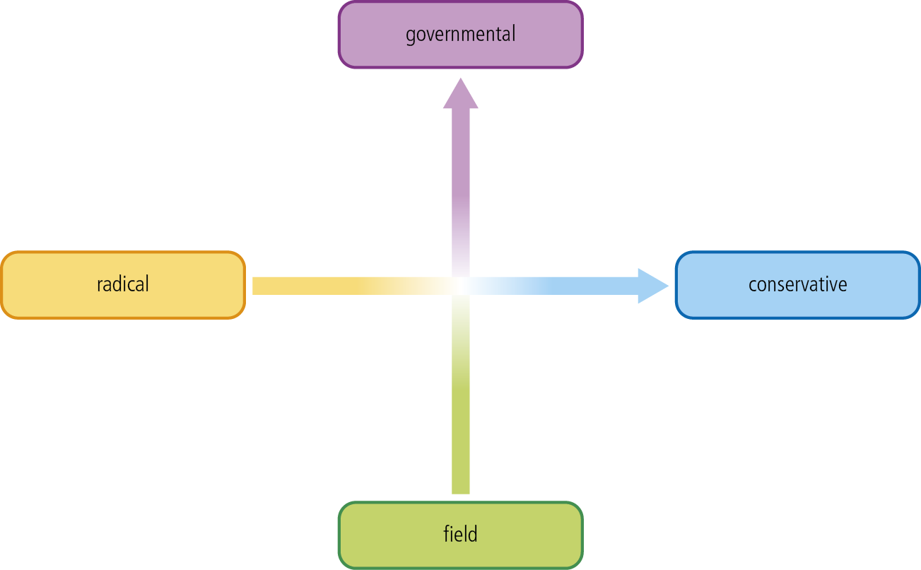
Figure 1
4 Use the table below to compare and contrast UNEP (an IGO) and Greenpeace (an NGO). [8 marks]
 | UNEP – an IGO | Greenpeace – an NGO
Use of media
Speed of response

Political pressures

Public image
Legislation
Agenda
Funding
Extent of geographical influence

5 What is the mission statement of UNEP? [1 mark]

6 When was UNEP formed? [1 mark]

7 What are UNEP’s responsibilities? [3 marks]

8 What are UNEP’s priority areas? [2 marks]

9 What is the World Conservation Strategy (WCS)? Who set it up and why? [3 marks]

10 What are the main objectives of the WCS? [3 marks]

11 When planning conservation strategies, certain arguments are likely to be more influential than others. Which arguments do the WCS focus on, and why? [3 marks]

12 What were the aims of the ‘Earth Summit’ of 1992? [3 marks]

13 What is Agenda 21? [1 mark]

14 Why is it called Agenda 21? [1 mark]

15 What is Local Agenda 21 (LA21)? Are there any LA21 programmes in your local area? [4 marks]

