Productivity
- Define the following terms:
Primary productivity:

Secondary productivity:

Gross productivity:

Net productivity:
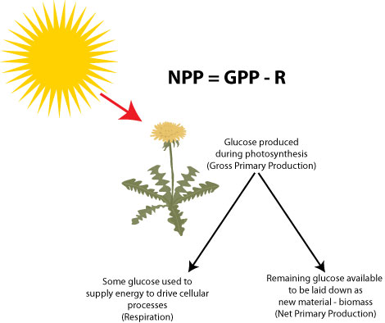

Biomass:

- What can you see happening in the diagram? How would you calculate GPP, NPP and respiration (write calculations)?

- Explain why gross primary productivity is always higher than net primary productivity.

- What can you see happening in this diagram? How would you calculate GSP, NSP and respiration (write calculations)?
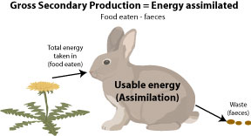

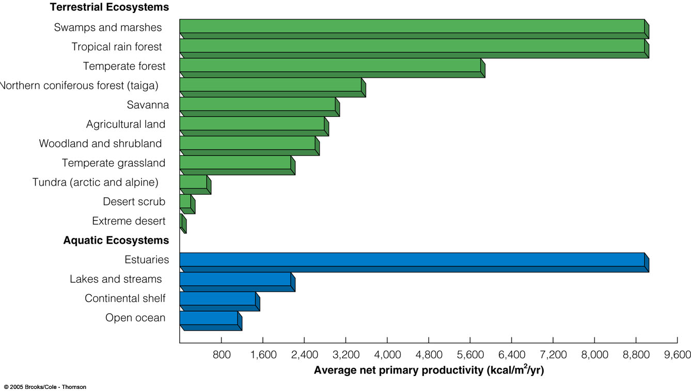
- Look at the chart of net primary productivity and list the areas that produce the most and the least NPP.

- The following passage outlines some of the energy flow in an ecosystem.
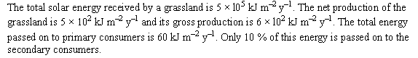

From the IB QuestionBank CDRom

Calculate the efficiency (in %) of the conversion of light energy into gross production.

- Study the energy flow diagram below.
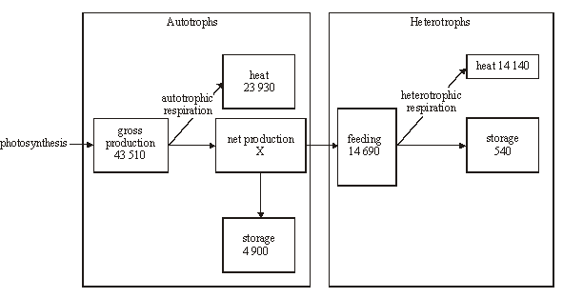
From the IB QuestionBank CDRom
- Calculate the net primary productivity of the autotrophs.

- Calculate the percentage of energy lost as heat in:

- Autotrophs

- Heterotrophs

- Suggest reasons for the differences in energy loss as heat between autotrophs and heterotrophs.

