Acid Rain Project

Acid deposition is a regional problem rather than a global problem. The areas that are downwind of major industrial regions are affected by acid rain if the industries produce sulfur dioxide and nitrogen dioxide, and the damage done by acid rain depends on the local buffering capacity of the soil.

Answer the following and submit the work to Managebac

Be sure if you directly quote a source, that you use quotation marks and cite the author of what was written. Include a bibliography of all resources used. Suggestions are given below.

- State the pH of natural rain.

- State the name of the gas that causes rain to be naturally acidic.

- Define the term acid deposition.

- Name two gaseous pollutants, which make rain acidic and state their human source. (Note: a human source is an anthropogenic source)

- State the natural sources of these gases.

- Define the term “buffering capacity”.

- Describe the leaching of calcium and other nutrients from soil by acidic rain.

- List direct and indirect effects of acid rain on forests.

- State the effect of acid rain on small aquatic organisms in lakes and rivers.

- Describe the effect of aluminium ions on fish.

- State the effect of acid rain on building materials and architecture.

- Evaluate the use of liming lakes and adding limestone to soil to neutralise the acid. Is it cost effective?

- Describe how alkaline scrubbers reduce sulfur dioxide emissions. Name the substance added to neutralise the acid in a scrubber.

- Evaluate the use of catalytic converters to lower nitrogen oxide emissions.

- Outline how coal can be cleaned to remove the sulfur, and how this lowers sulfur emissions.

- Find an example of an international agreement that works to reduce the emissions that cause acid rain. Include a bibliography.

- Describe and evaluate pollution management strategies for acid deposition at each of the three levels of pollution management. (Refer to the next page.)

Level 1: Measures to reduce fossil fuel combustion should be considered, for example, reducing demand for electricity and private cars and switching to renewable energy.

Level 2: Refer to clean-up measures at “end of pipe” locations (points of emission). Consider the role of international agreements in effecting change.

Level 3: The cost-effectiveness of spreading ground limestone in Swedish lakes in the early 1980s provides a good case study.
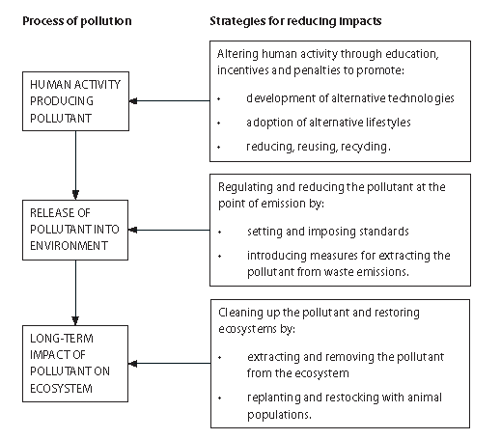
Resources: You can start by using these links and then look for other resources as necessary:
The textbook pages 295-299

Acid rain from the USA Environmental Protection Agency
http://www.epa.gov/acidrain/

Acid Rain from Environment Canada
http://www.ec.gc.ca/eau-water/default.asp?lang=en&n=FDF30C16-1

Include a bibliography and understand that turnitin.com will scrutinise your work when you submit.

