Soil Texture Triangle Activity

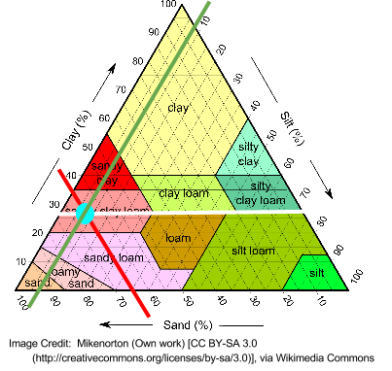
Using the soil texture triangle, scientists have created classes which break the distribution of particle sizes (soil textures) into 12 categories: clay, sandy clay, silty clay, sandy clay loam, clay loam, silty clay loam, sand, loamy sand, sandy loam, loam, silt loam, silt. Follow the steps below to determine the textural class name of your soil sample:
- Determine the percent sand of your sample and find that number on the bottom of the triangle.
e.g. If your sample is 65% sand then you draw a line at that point on the triangle (red).
- Draw another line to correspond to the percent clay. Let’s say you had 27% clay (white).
- Where the lines intersect should also indicate percent silt. On the triangle, you can see that it is about 8% silt (green).
- Wherever your lines intersect indicates the soil type you have. In this situation, with 65% sand, 27% clay, and 8% silt, it is sandy clay loam.

Soil Texture Practice

Part 1: Use the soil textural triangle to determine the soil texture name and fill in any blanks noting that the sum should always add up to 100 percent.

 | % Sand | % Silt | % Clay | Texture Name | Properties
a) | 75 | 10 | 15 | Sandy Loam | Water infiltration, aeration, workability
b) | 10 | 83 | 7
c) | 42 |  | 37
d) |  | 52 | 27
e) |  | 35 | 50
f) | 30 |  | 21
g) | 5 | 70
h) | 55 |  | 40
i) |  | 45 | 10

Part 2: Using the table below, complete the Properties section above for each of the soil samples analyzed.

Soil texture | Nutrient­holding capacity | Water­ infiltration capacity | Water­holding capacity | Aeration | Workability
Clay | Good | Poor | Good | Poor | Poor
Silt | Medium | Medium | Medium | Medium | Medium
Sand | Poor | Good | Poor | Good | Good
Loam | Medium | Medium | Medium | Medium | Medium

