THE GREAT OCEAN CONVEYOR BELT
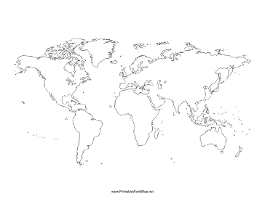

Key notes:

