Global Warming Information Pack
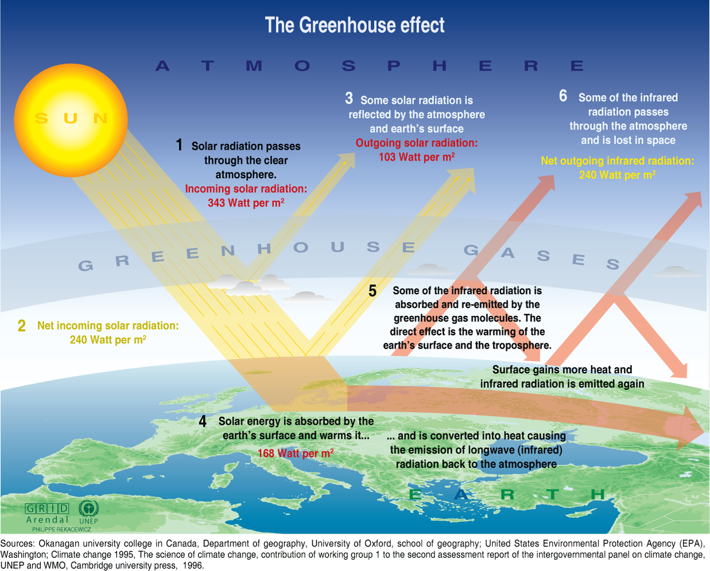
Global warming is the increase in the average temperature of Earth's near-surface air and oceans since the mid-20th century and its projected continuation.
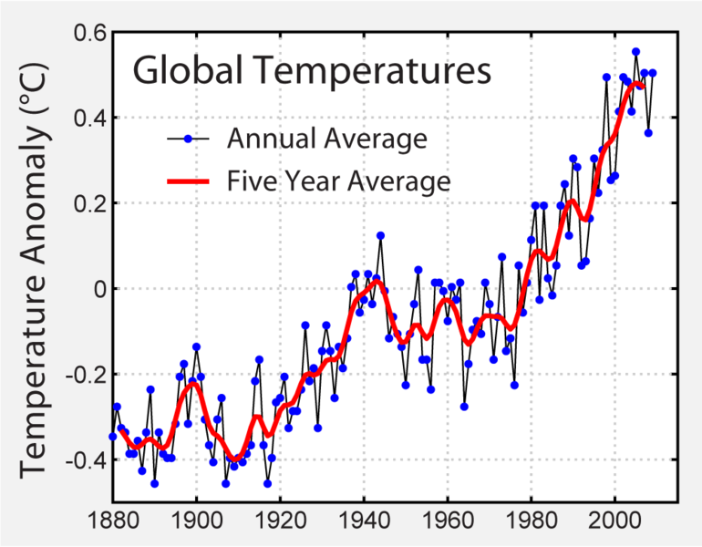
The Greenhouse effect: As sunlight from the Sun enters the Earth’s atmosphere, it bounces off the surface. When entering the atmosphere again, greenhouse gases scatter the heat, sending it back to Earth, thus heating the planet. This is necessary because, without it, the planet would cool off too much at night. The Greenhouse effect is a good thing, but the problem here is the overabundance of greenhouse gases
What is causing Global Warming?
We are releasing the greenhouse gases:
- Carbon dioxide (CO₂) and carbon monoxide (CO)
- Methane (CH₄)
- Nitrous oxide (N₂O)
These are building up in our atmosphere, by the following activities:
- Transportation -Cars, trains, buses, aeroplanes = Produces CO₂ and N₂O
- Power generation = Creates all types of greenhouse gases
- Waste processing = Produces methane
- Domestic use - heating the house, powering electric devices, etc. = Mostly CO₂
- Deforestation - cutting down trees prevents them from taking carbon dioxide out of the atmosphere. Burning the wood releases all of the carbon dioxide stored in the trunk
- Agriculture –Tractors using fossil fuels, cow waste contains methane due to the bacteria used in digestion grass
“Greenhouse gases” trap the Sun’s heat in the same way as glass does in a greenhouse. They allow solar radiation to enter the Earth’s atmosphere and then absorb the heat reflected back up by the Earth.
Carbon dioxide is a byproduct of burning carbon substances – trees and fossil fuels e.g. coal, oil, and gas. Methane, 20 times more powerful than carbon dioxide in trapping the Sun’s heat, it is also produced by agriculture, mining, and industry. The percentage of these gases increased by about 25 percent over the last 150 years.
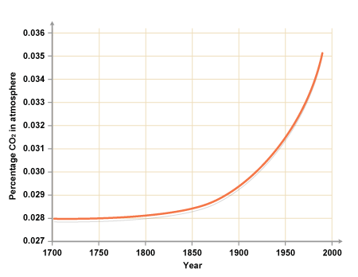
Carbon dioxide in the atmosphere has risen at a higher rate since the 19th century.

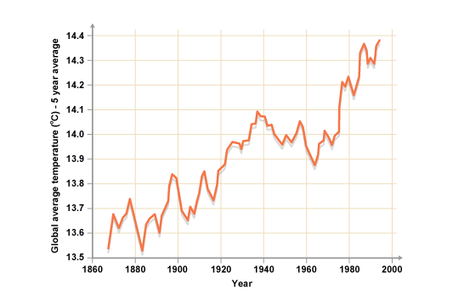
The temperature of the Earth has risen over the years

Along with this has come the increasing presence of another kind of greenhouse gas in the atmosphere, exclusively man-made gases like those used in aerosol spray cans. At the same time, cutting down forests and other changes in land use has crippled the natural processes whereby trees and other plants remove carbon dioxide from the air thus disrupting the carbon cycle:
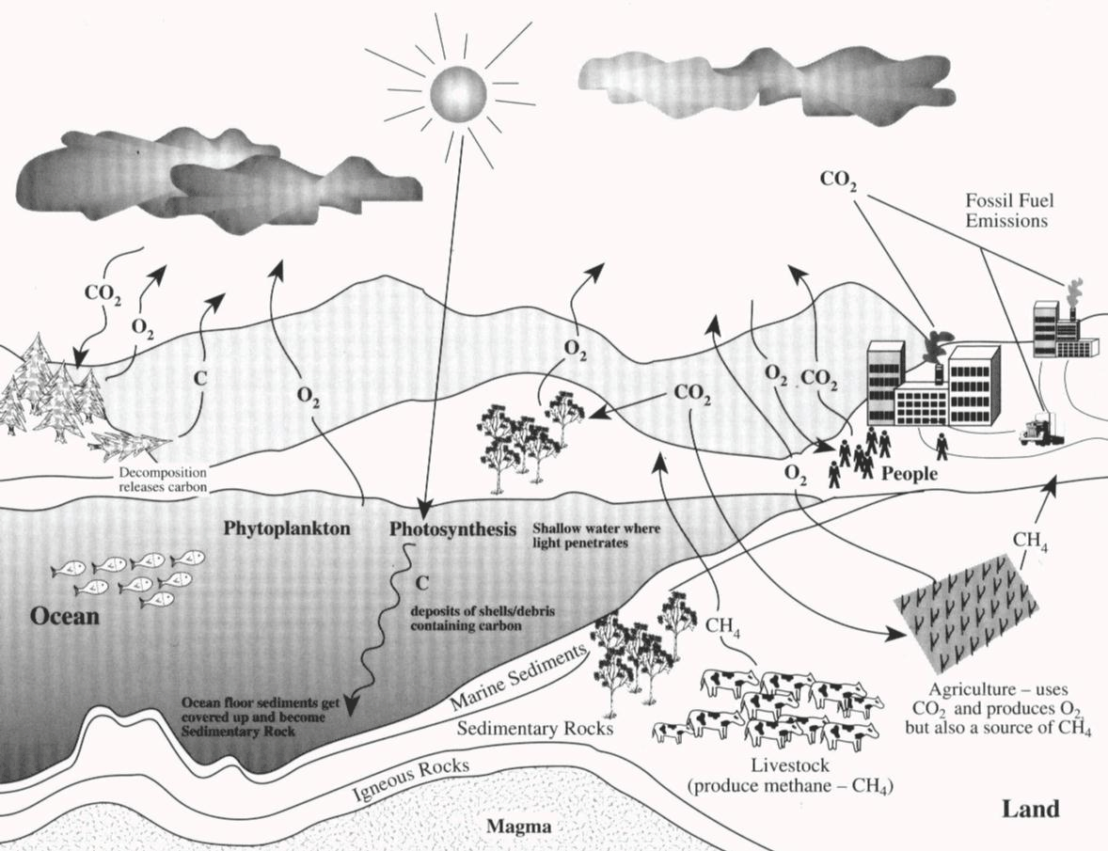
Greenhouse gases are not the only factor in global warming. The Earth went through periods of heating and cooling long before humanity produced enough greenhouse gases to make a big difference, and even in the last 150 years, there have been cycles of warmer and cooler weather. The relationship between greenhouse gases and other factors is still under study. But research has led most scientists to conclude that the solar energy trapped by greenhouse gases is playing the main role in driving the rapid increase in the Earth’s temperature we are seeing today.

Current beliefs
Scientists, politicians and industrialists continue to debate the causes of global warming, with some arguing that it is a natural process that's been going on for centuries. However, the Intergovernmental Panel on Climate Change (IPCC) - established by the United Nations in 1988 - has stated that evidence suggests that human activity does affect global warming, in particular through the release of greenhouses gases and the use of aerosols.
There is also debate over how quickly the Earth is warming up. Some scientists estimate that atmospheric temperatures could rise by 1.4° - 5.8°C in the next 100 years. Others believe that they will rise more slowly.
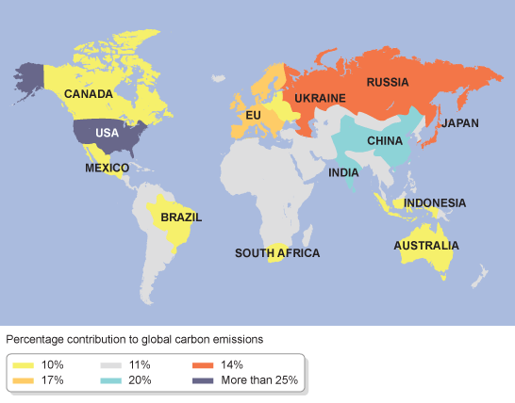
Global carbon emissions
Whatever the causes and timescale, the implications of global warming are very serious.
- The map above shows which countries are responsible for the most emissions. LEDCs want to develop and to catch up with MEDCs and this normally means using more energy and burning more fuel. So global warming could threaten development.

It has taken a long time for it to be generally accepted that the increase in carbon dioxide in the atmosphere is a cause of global warming. There has been uncertainty in some of the data but this has reduced as more data has been collected. Computer models help us to predict that an increase of only a few degrees will cause changes to the Earth's climate. This is why it is important to attempt to combat global warming, for example by reducing our reliance on fossil fuels.

Effects
Global warming could cause:
- climate change
- extreme weather conditions in some areas
- Climate change may make it impossible to grow certain food crops in some regions. Melting polar ice, and the thermal expansion of sea water could cause rising sea levels and the flooding of low-lying land.
- Global warming could melt the world's ice caps and glaciers, leading to an increase in sea levels. Some scientists estimate that over the next hundred years sea levels could rise by between 10cm and 90cm - making many coastal areas around the world uninhabitable.
- Global warming could also affect the weather patterns, leading to more droughts, flooding and extreme weather, such as hurricanes.
- In Britain, we are largely unaffected by the dangerous weather of the tropics, such as hurricanes or severe droughts. But some climatologists argue that the UK climate is changing as a result of global warming - with the possibility of more frequent floods, water shortages, and extreme weather conditions

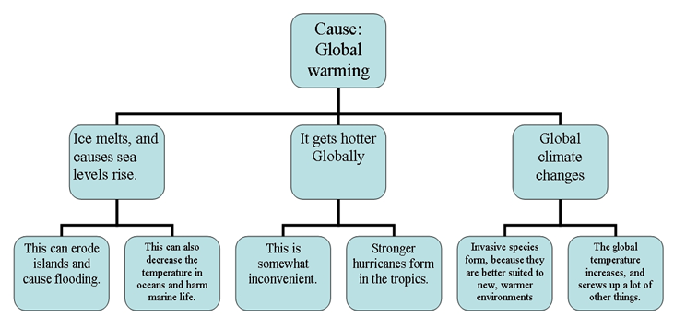

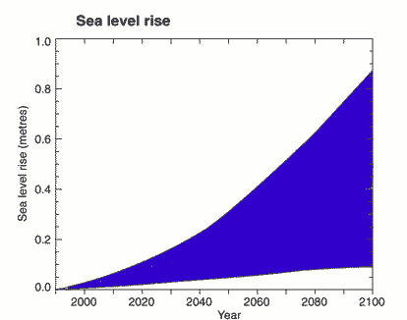
The projected sea level increase in the 21st century.
Ways to reduce Global Warming
- Reduce, Reuse, Recycle
- Use less heat and air conditioning
- Change a light bulb
- Drive less
- Plant trees
- Conserve energy or switch to renewable energy sources e.g. solar, hydro, wind.

Carbon credits
The carbon credits scheme is aimed at reducing greenhouse gas emissions. It is based on the “polluter pays principle” according to how much pollution they generate. The idea is that people are encouraged to pollute less, as it will cost them less in carbon taxes.

Case study: London Congestion Charge
Drivers are charged for driving in the congestion charge zone in central London. The aim is to discourage drivers from using the zone during peak hours and use public transport instead, thereby reducing congestion, the time spent in queues, the pollution generated and the cost to the economy. The money generated is used to improve public transport, eg older London buses which generate more pollution have been removed from service.

The Results
- Traffic congestion, accidents, and pollution levels have all been reduced.
- There has been increased investment in public transport.
- Bus services are more reliable.
- Retail sales inside the congestion charging zone have increased.
Global level
To tackle a global problem requires global effort and the Kyoto Agreement was a conference whereby governments signed up to an agreement committing themselves to reducing their emissions of greenhouse gases, particularly carbon dioxide. On the 16th February 2005, the Kyoto agreement came into force. The UK has committed itself to reducing the emissions of carbon dioxide to approximately 180 million tonnes by 2008 and domestic carbon dioxide to 130 million tonnes by 2010 or they will be penalised (fined).

