TOPIC 4.4 –WATER POLLUTION

Significant ideas:
- Water pollution, both groundwater and surface water, is a major global problem the effects of which influence human and other biological systems
There are a variety of freshwater and marine pollution sources

Define the following types of pollution with an example of each

Type | Definition | Example
anthropogenic
point source
non-point source
organic
inorganic
direct
indirect

Types of aquatic pollutants include organic material, inorganic plant nutrients (nitrates and phosphates), toxic metals, synthetic compounds, suspended solids, hot water, oil, radioactive pollution, pathogens, light, noise, and biological (invasive species)

A wide range of parameters can be used to directly test the quality of aquatic ecosystems, including pH, temperature, suspended solids (turbidity), metals, nitrates and phosphates

Describe the difference between direct and indirect measurements of water pollution

Give some examples of indirect and direct measurements of water pollution

Direct | Indirect

Biochemical oxygen demand (BOD) is a measure of the amount of dissolved oxygen required to break down the organic material in a given volume of water through aerobic biological activity. BOD is sued to indirectly measure the amount of organic matter within a sample

Define BOD:

How is BOD calculated?

How is BOD measured?

Some species can be indicative of polluted waters and be used as indicator species

Below is a diagram of a river and its surrounding area.
The river flows from west to east and passes a factory, arable farmland and woodland. It has been divided into four sections, labelled A, B, C and D.

The river is going to be surveyed to assess its water quality, using the following invertebrates as indicators of different pollution levels:

High pollution | Moderate pollution | Slight pollution | Unpolluted
Sludgeworm  Rat-tailed maggot | Water louse  Bloodworm | Freshwater shrimp  Caddisfly larva | Mayfly larva  Stonefly larva

Referring to the river diagram and the table above, answer the following questions:

- If the factory is polluting the river and reducing oxygen levels, which species might you expect to find in the different sections of the river?

A -

B -

C -

D -

- If mayfly larvae have been found to be abundant in section B, what might this tell you?

- High numbers of sludgeworms and bloodworms were found in section C. What possible explanations might there be?

- How could you investigate this further?

- Both fertilisers and pesticides are used on the arable farmland. Explain how these could potentially affect invertebrates living in the river.

- Who might want to survey the river to find out if the water is polluted?

- Can you think of any other species which could be used to indicate that the river is clean and healthy? Explain your answer.

A biotic index indirectly measures pollution by assaying the impact on species within the community according to their tolerance, diversity and relative abundance

The Hilsenhoff Biotic Index (HBI) estimates the overall tolerance of the community in a sampled area, weighted by the relative abundance of each taxonomic group (family, genus, etc.). Organisms are assigned a tolerance number from 0 to 10 pertaining to that group's known sensitivity to organic pollutants; 0 being most sensitive, 10 being most tolerant.
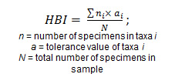
An example of how one would use this equation to calculate a biotic index looking at water quality of a stream

Can you complete the rest of the table?

Species (taxa) | Tolerance Value (a) | Specimens (n) | Product (n x a)
Stonefly | 2 | 5 | 10
Mayfly | 4 | 3
Caddisfly | 3 | 7
 | Total | Tn =15 | T(nxa)

To calculate the Hilsenhoff Biotic Index number (HBI):

Divide the total product T(n x a) by the total number of specimens (Tn)

HBI = _____________

Use the table below to determine the health of the stream in the example above:

The water quality rating of the stream is __________________

Evaluate the uses of indicator species and biotic indices in measuring aquatic pollution

Other than pollution, why else may indicator species be absent from a specific area?

What is the impact of the answer on the reliability of using indicator species to assess water quality?

Biodegradation of organic material utilizes oxygen which can lead to anoxic conditions and subsequent anaerobic decomposition which leads to formation of methane, hydrogen sulfide and ammonia (toxic gases)
Eutrophication can occur when lakes, estuaries and coastal waters receive inputs of nutrients (nitrates and phosphates) which result in an excess growth of plants and phytoplankton

Use the animation from the link below to draw a flow chart showing the process of eutrophication in the space below. Try and consider it in terms of inputs, processes and outputs. Perhaps the shapes/colours you use in your diagram could reflect this?

http://nroc.mpls.k12.mn.us/Environmental%20Science/course%20files/multimedia/lesson78/animations/5a_Lake_Eutrophication.html

Explain the process and impacts of eutrophication

List the impacts of eutrophication below:
1.
2.
3.
4.
5.

Dead zones in both oceans and freshwater can occur when there is not enough oxygen to support marine life

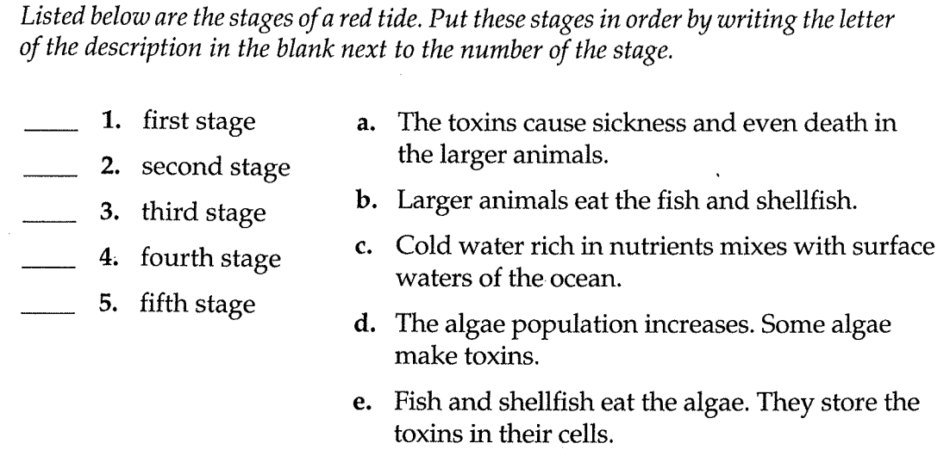

Application of pollution management strategies to include:
- Reducing human activities that produce pollutants (e.g. alternatives to current fertilisers and detergents)
- reducing release of pollution into the environment (e.g. treatment of waste water to remove nitrates and phosphates)
- removing pollutants form the environment and restoring ecosystems (e.g. removal of mud from eutrophic lakes and reintroduction of plant and fish species
Evaluate pollution management strategies with respect to water pollution
For the empty evaluation column, try and right one advantage and disadvantage for each of the management strategies listed

Strategy for reducing pollution | Example of action | Evaluation of strategy
Altering the human activity producing pollution | Ban or limit detergents with phosphates
 | Use ecodetergents with no phosphates or new technology in washing machines
 | Plant buffer zones between the fields and water courses to absorb excess nutrients
 | Stop leaching of slurry (animal waste) or sewage from their sources
 | Educate farmers about more effective timing for fertilizer application
Regulating and reducing pollutants at point of emission | Treat wastewater before release to remove phosphates and nitrates
 | Divert or treat sewage waste effectively
 | Minimize fertilizer dosage on agricultural lands or use organic matter instead
Clean up and restoration | Pumping air through lakes
 | Dredging sediments with high nutrient levels from the river and lake beds
 | Remove excess weeds physically or by herbicides and algicides
 | Restock ponds or water bodies with appropriate organisms

