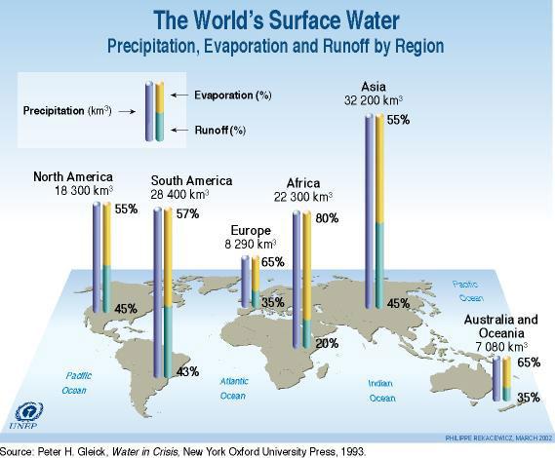

1. Define

* Precipitation -
* Evaporation -
* Runoff - (3)

1. Rank order the 6 continents in terms of the following

**Precipitation Evaporation Runoff**

1. 1. 1.

2. 2. 2.

3. 3. 3.

4. 4. 4.

5. 5. 5.

6. 6. 6. (18)

3. **Describe & explain** the patterns that exist in the levels of precipitation, evaporation and runoff for the continents. Use a separate sheet. (6)

**The World’s Water Cycle & Residence Times of World’s Water**

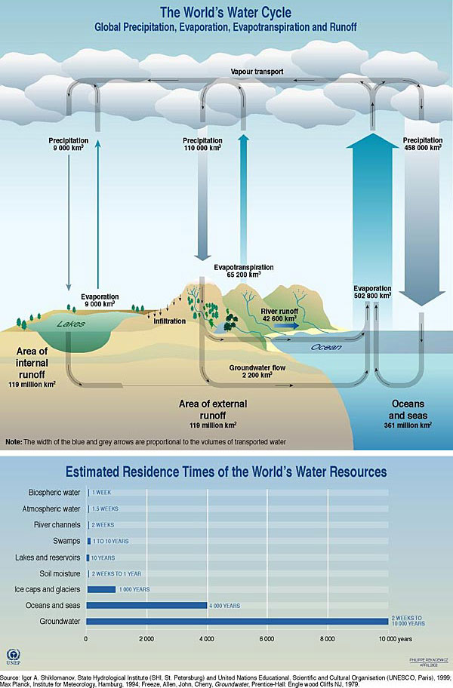

1. What proportion of the total rain evaporated from the ocean returns directly to the ocean as precipitation?

__________________________________________________________

2. How many km3 of this evaporated sea water falls over the land?

__________________________________________________________

3. What is the total value of terrestrial evapo-transpiration? There are two values to add together.

__________________________________________________________

4. How many km3 of terrestrial runoff and flow are returned to the sea?

__________________________________________________________

5. Using the table comment on the amount of water stored out of reach of human, plant and animal populations.

___________________________________________________________________________________________________________________________________________________________________________________________________________________________________________________________________________________________________________________________________________________________________________________________________________________________________________________

**Due to rapid population growth, the potential water availability of Earth's population decreased from 12 900 m3 per capita per year in 1970 to 9 000 m3 in 1990, and to less than 7 000 m3 in 2000**

**It is estimated that 3 billion people will be in the water scarcity category of 1 700 m3 per capita per year by 2025 (UNEP, 2002).**