Natural Capital Review Questions

1. Of which type of natural capital is fisheries an example?
A. Renewable B. Replenishable
C. Non-renewable D. Recyclable

2. What term is used to describe non-living natural resources that depend directly on the sun’s energy?
A. Non-renewable natural capital B. Renewable natural capital
C. Biotic natural capital D. Replenishable natural capital

3. Which statement is correct?
A. Only resources that have a commercial value are considered to be natural capital.
B. Nuclear power is a replenishable natural resource.
C. Natural capital is a resource that can always produce an income.
D. A catch of tuna fish is a form of natural income

4. Which of the following combinations of harvesting techniques would allow the exploitation of this resource to be fully sustainable?

I. Removal of the entire natural income of the forest
II. Removal of the entire natural capital of the forest
III. Use of petrol/gasoline-driven machinery for harvesting and transport

A. I and III only
B. III only
C. I only
D. I and II only

5. An area of forest contains a volume of 2.5 million m³ of timber. On average, each year bushfires destroy 100 000 m³ and pests destroy 100 000 m³ of timber. Normal tree growth adds 200 000 m³. What is the approximate sustainable yield of the forest in m³ yr ⁻¹?

A. 50 000 B. 1 550 000 C. 0 D. 350 000

6. Which could not be described as natural capital?
A. A stand of forest on a hillside
B. The fish stocks of a fish farm
C. The fish harvested from the inshore waters of one country in one year
D. A waterfall

7. Sustainable yield can be defined as

I. annual growth and recruitment - annual death and emigration.
II. (total biomass at time t+1) −(total biomass at time t) .
III. the highest rate at which natural capital can be exploited without reducing its original stock.

A. I and II only
B. I and III only
C. II and III only
D. I, II and III

8. If the harvesting of a fish population were to exceed the sustainable yield in one year, this would mean
A. the natural capital had been reduced but the natural income had increased.
B. the natural capital remained the same but the natural income had been reduced.
C. the natural capital had been reduced and the natural income would be reduced in the
following year.
D. the natural capital remained the same but the natural income would be reduced in the following year.

9. Four examples of natural capital are
(i) water stored in a stratum of permeable rock;
(ii) crude oil stored in an oil-trap in rocks;
(iii) a stand of coniferous trees in a 25 year old plantation;
(iv) a seal colony on an Antarctic island.

To which of the three broad classes of natural capital (given below) do each belong?
R = renewable
N = non-renewable
Rp = replenishable

(i) (ii) (iii) (iv)
A. N N R R
B. Rp Rp Rp N
C. Rp N R R
D. Rp N R Rp

10. In a deer population of 1000, each year an average of 100 die from natural causes and 250 are born. Assuming no immigration or emigration, the sustainable yield is

A. 100. B. 150. C. 350. D. 1150.
11. A particular resource depends on the energy of the sun but not on living processes. Which of the following could represent that resource and the correct class to which it belongs?
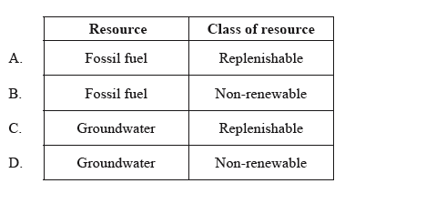
12. Which row in the table includes examples of natural capital and natural income of a tropical forest?
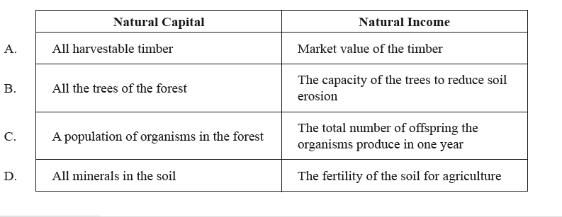

13. Four examples of natural capital are listed below.
(i) a nickel ore deposit in the Australian outback
(ii) a population of deer in a forest reserve
(iii) ozone in the upper atmosphere
(iv) the forest cover of an uninhabited Pacific island
In which of the three classes of natural capital does each belong?

A. non-renewable, renewable, replenishable, renewable
B. renewable, renewable, non-renewable, renewable
C. replenishable, replenishable, renewable, non-renewable
D. non-renewable, renewable, renewable, replenishable

14. a) Explain what is meant by the terms natural capital, natural income and sustainable yield; giving examples of each.

b) List examples of economic, ecological, scientific and intrinsic value from a named natural capital.

c) Explain, with examples, how the sustainable yield of a resource can be determined and evaluate how useful this concept is in the management of resources.

