Biomes of the World
Biomes are formed as a result of the climate present at a site. Robert Whittaker, an American ecologist, plotted rainfall vs. temperature for points all over the globe on a single graph (see below). He then looked at what biomes had developed at those sites, and was able to group the different biomes according to mean annual temperature and precipitation, as the shaded areas in the graph below indicate. There are several variations on these diagrams, one of them is:
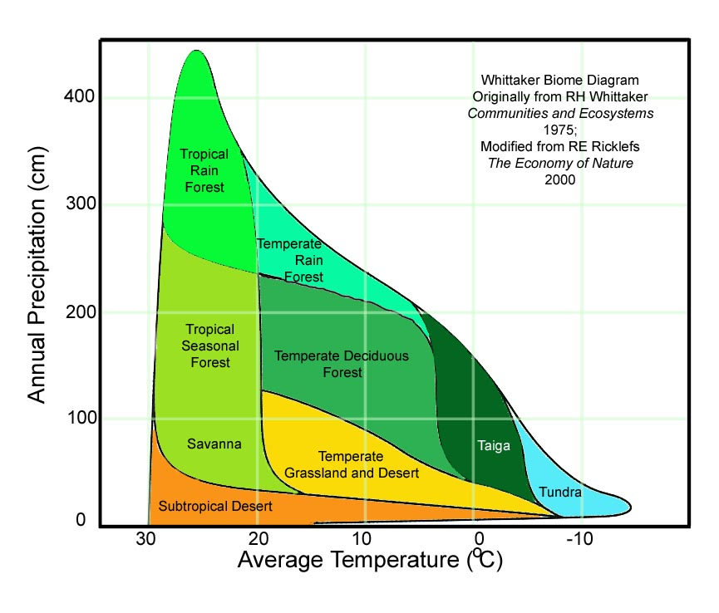
Note that in Whittaker's diagram the temperature axis is reversed; that is temperature goes DOWN as you move to the right. Theoretically, if you know the average temperature and precipitation for a site, you should be able to predict what biome will develop there. Try your hand - look at the values in the table overleaf, compare them to the diagram above, and predict the biome.

Place | Average Temperature ºC | Annual Precipitation (cm) | Biome
La Selva,  Costa Rica | 22.1 | 403.0 | Tropical Rain Forest
Marietta,  Ohio | 12.0 | 105.0 | Temperate Deciduous Forest
Pasadena  California | 18.2 | 51.8 | Savanna
Ferron,  Utah | 8.8 | 20.9
Tucson,  Arizona | 21.1 | 21.9
Santa Rosa,  Costa Rica | 26.0 | 165.0 | Tropical Seasonal Forest
Brazzaville,  Congo | 25.0 | 137.0 | Tropical Seasonal Forest
Lambarene,  Gabon | 25.7 | 195.0 | Tropical Seasonal Forest
Amauulu,  Hawaii | 20.0 | 410.0 | Tropical Rain Forest
Toolik Lake,  Alaska | -8.8 | 18.0 | Tundra
Beijing,  China | 11.8 | 63.5 | Temperate Grassland
Seoul,  South Korea | 11.2 | 137.0 | Temperate Deciduous Forest
Archbold Biological Station | 29.1 | 131.0 | Tropical Seasonal Forest*
Everglades National Park | 28.1 | 159.0 | Tropical Seasonal Forest*

