Simpson Index

Calculate the Diversity index of the meadow:

1. Multiply the number in each

separate species (n) by n-1.

1. Determine the total for all

n(n-1) values.

1. Determine the total number

of individuals (N) in the meadow.

1. Substitute the calculated values

in the Diversity Equation:



Calculate and compare the diversity site A and B:

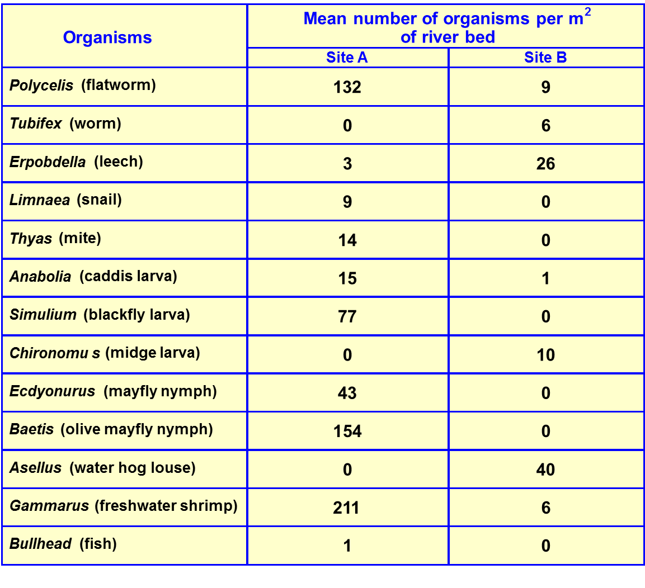

Site A:

|  |  |  |
| --- | --- | --- |
| Species | Number (n) | n(n-1) |
|  |  |  |
|  |  |  |
|  |  |  |
|  |  |  |
|  |  |  |
|  |  |  |
|  |  |  |
|  |  |  |
|  |  |  |
|  |  |  |
|  |  |  |
|  |  |  |
|  |  |  |
|  | N = ∑n | ∑n(n-1) |

Site B:

|  |  |  |
| --- | --- | --- |
| Species | Number (n) | n(n-1) |
|  |  |  |
|  |  |  |
|  |  |  |
|  |  |  |
|  |  |  |
|  |  |  |
|  |  |  |
|  |  |  |
|  |  |  |
|  |  |  |
|  |  |  |
|  |  |  |
|  |  |  |
|  | N = ∑n | ∑n(n-1) |