**SAMPLING POPULATION SIZE**

**CLASS COPY**

***Purpose:*** To practice using different methods of sampling populations.

*Write the purpose in your lab book*

***Introduction***

One of the aims of ecology is to search for, and attempt to explain, patterns of species distribution and abundance. In today’s lab we will learn some methods for counting organisms, that is, for determining abundance.

How do we go about determining species abundance? At first glance this seems a silly question with an obvious answer: just count ‘em! However, we generally do not have the time, resources, ability, or interest to count every organism in the population. Thus, we will count only a **sample** (a small subset) of the population, and then use this sample to estimate the actual population size. This then brings up a second problem…how do we accurately sample our population, so that we can make the best possible guess of the population size? There is no one correct answer to this question. Instead, the method used will depend on the organism and its behavior; for instance, different methods are used for sedentary organisms (like plants) than very active organisms (like squirrels).

For our lab, we will examine four methods of sampling population size. We will use **point sampling**, the **quadrat** technique, a **transect sampling,** and a **mark-recapture** study. The first three techniques are used for plants or other relatively sedentary organisms, while mark-recapture is used for more mobile animals.

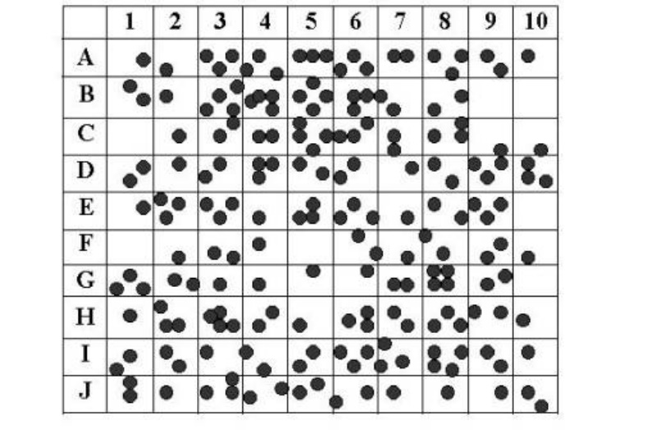

***MATERIALS:***

* A piece of butcher paper cut into a 1m X 1 m square. The paper represents the habitat you are sampling.
* A cup of beans. The beans represent the organisms which you are sampling.
* A ruler.
* A sharpie pen.

***Method 1: Point Sampling***

* Dump the cup of beans onto the paper.
* At each point in the habitat (i.e. A1, A2, A3… J8m J9, J10) record the presence or absence of an organism. To be considered present at the point, the ENTIRE organism must be within 1 cm of the line intersect. Record the result for each point in a data table.

*ANALYSIS:*

1. Determine the total number of organisms that were found within 1 cm of an intersection.
2. By sampling within 1 cm of a point, you sampled 4% of the overall habitat size. Knowing this, calculate the estimated total population size.
3. Now count all the beans actually in the habitat and find the percentage error in your estimate. To calculate percentage error, find the difference between the actual count and the estimated count. A difference is always positive, so subtract the smaller of the two numbers from the larger. Then, divide the difference by the actual count and multiply by 100. Please show your working.

|  |  |
| --- | --- |
| Difference  Actual count | spacexspace100space=space% Error |

***Method 2: Quadrant Sampling***

* Dump the cup of beans onto the paper.
* Determine which quadrats you will sample:
  + Tear a sheet of paper into 20 slips, each approximately 4cm x 4 cm.
  + Number 10 of the slips from 1 to 10 and put them in a small container.
  + Label the remaining 10 slips from A through J and put them in a second container.
  + Randomly remove one slip from each container. Write down the number-letter combination and find the grid segment that matches the combination.
  + Place the numbers and letters back into the cups before picking your next quadrant.
  + Repeat until you have identified 10 quadrats that you will sample.
* Count the number of beans in each of the 10 quadrats you are sampling. The ENTIRE organism must be in the quadrant in order for it to be recorded. Record the quadrat number-letter combination and the number of beans in a data table.

*ANALYSIS:*

1. Calculate the average population for a quadrant.
2. Multiply the average by the total number of quadrants (100). This is the population estimate for this area.
3. Now count all the beans actually in the habitat and find the percentage error in your estimate. To calculate percentage error, find the difference between the actual count and the estimated count. A difference is always positive, so subtract the smaller of the two numbers from the larger. Then, divide the difference by the actual count and multiply by 100.

|  |  |
| --- | --- |
| Difference  Actual count | spacexspace100space=space% Error |

1. In a complete sentence, explain why you drew paper slips, rather than just choosing 10 grid segments while doing quadrant sampling.

***Method 3: Transect Sampling***

* Dump the cup of beans onto the paper.
* You will sample the 9 transect lines between each letter on the grid (i.e. the line between A and B would be one transect line). For each transect line, record the number of organisms that fall within 1 cm of the line. The ENTIRE organism must be within 1 cm of the time in order for it to be recorded.

*ANALYSIS:*

1. Determine the total number of organisms that were found within 1 cm of a line.
2. By sampling within 1 cm of a line, you sampled 20% of the overall habitat size. Knowing this, calculate the estimated total population size.
3. Now count all the beans actually in the habitat and find the percentage error in your estimate. To calculate percentage error, find the difference between the actual count and the estimated count. A difference is always positive, so subtract the smaller of the two numbers from the larger. Then, divide the difference by the actual count and multiply by 100. Please show your working.

|  |  |
| --- | --- |
| Difference  Actual count | spacexspace100space=space% Error |

***Method 4: Mark-Recapture Sampling***

* Dump the cup of beans onto the paper.
* Have one group member close their eyes and “trap” the beans by placing their hand over a random section of the habitat.
* Count the number of trapped beans. This is your first trapping sample (M). Record your answer in a data table.
* Mark these beans with a sharpie.
* Return ALL bean to the cup (marked and unmarked). Shake the cup.
* Dump the cup of beans onto the paper.
* Without looking, grab another handful of beans. This represents your second trapping sample (n). Count them and record your answer in your data table.
* How many of the beans in your second trapping sample were already marked? This is your (R) value. Count them and record your answer. Return this trapping sample (white and red) to the cup.
* Count the actual number of beans in your sack. Record this number.

ANALYSIS:

1. Use the Lincoln-Petersen index to calculate population size:

**N = (n M) / R**

1. where N = estimated total population size, M = the number of individuals caught and marked in the initial catch, n = the total number of individuals caught in the second catch, and R = the number of marked individuals caught in the second catch. Be sure to show your work!!
2. Find the percentage error in your estimate. To calculate percentage error, find the difference between the actual count and the estimated count. A difference is always positive, so subtract the smaller of the two numbers from the larger. Then, divide the difference by the actual count and multiply by 100.

|  |  |
| --- | --- |
| Difference  Actual count | xspace100space=space% Error |

**OVERALL ANALYSIS**

1. Which method was most accurate in estimating the population size? Why?
2. In general, explain what changes could you make to a sampling procedure to reduce your percentage error?
3. Which method(s) would work best for sampling plant populations? Why?
4. Which method(s) would work best for sampling animal populations? Why?