Deepwater horizon BP oil disaster

This is a detailed case study for you to use to exemplify the cost of environmental damage (as well as social and economic) to use in short answer but especially essay questions on pollution management.

Background to the spill
http://ocean.si.edu/gulf-oil-spill - use this link to fill in background information on the oil spill. When and where did it happen? For how long? What were the immediate impacts?

Who/ What /Why /Where /When /How?

Anatomy of the spill - Where did the oil go?

http://ocean.si.edu/gulf-oil-spill-interactive - use this interactive resource to describe where and how the oil spread.
http://www.nytimes.com/interactive/2010/05/01/us/20100501-oil-spill-tracker.html?hp&_r=1& - use this interactive to create a timeline of key events in the BP oil spill.
Map of the spill - label site of explosion, area of spill, land areas affected. (use a key if needed).
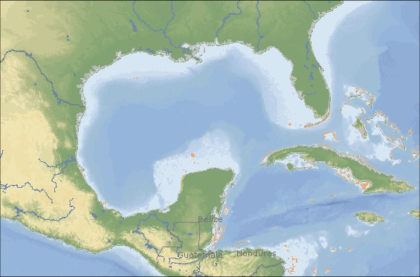

A timeline of key events. (use a flow chart if necessary).

Impacts of the oil spill: environmental, social and economic
http://ocean.si.edu/ocean-videos/gulf-oil-spill-effects-marine-life - watch the video to help summarise the environmental impacts:
Type of impact | Summary of key impacts
Environmental (consider surface ocean/deep ocean/coastline/ecosystems)

Social (consider oil community/local shorefront communities)

Economic (sea fishing industry/oil industry/tourism/compensation)

The cleanup operation - what techniques were used? Did they work?
http://ocean.si.edu/ocean-videos/science-time-crisis-oil-spill-pioneers - watch this video on how environmental teams have learnt to deal with these types of disasters. Also evaluate these techniques - how effective are they? Think of the 3 R’s (reduce, reuse, recycle)
Type of technique | Details of management
Physical

Chemical

Where does most oil ocean pollution come from?
https://seawifs.gsfc.nasa.gov/OCEAN_PLANET/HTML/peril_oil_pollution.html- not from oil spills!
Summarise (using data) where most oil pollution comes from.

Conclusion - will this happen again? What are the alternatives?

Discuss below the advantages/disadvantages of continuing with oil as an energy resource or whether there is a viable alternative.

Oil as a resource? - advantages/disadvantages | What are the alternatives?
 | for example - http://www.theguardian.com/environment/2015/oct/26/morocco-poised-to-become-a-solar-superpower-with-launch-of-desert-mega-project

