**PREDATORS AND PREY IN THE GARDEN**

j0101436AN01063_j0101436AN01063_j0101436AN01063_j0101436AN01063_

Imagine a garden with a stream running through it. This is a habitat for toads, slugs and plants. The toads feed on slugs. The slugs feed on the plants. Normally, the numbers of toads and slugs reach a balance. Something rather unusual happened last year. Look at the following graph:

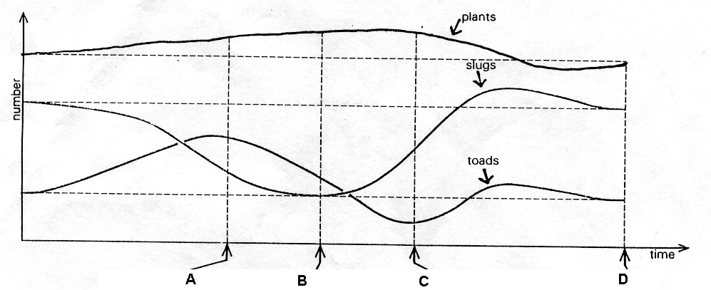

1. (a) What happened to the toad population up to point A?

(b) Toad population size normally relies on the survival of their tadpoles. Suggest what may have happened this year.

1. (a) Describe and explain what effect this change in the toad population had on the slug population up to point A.

(b) Describe and explain what effect this change in the slug population had on the plant population up to point A.

1. (a) Describe and explain what has happened to the toad population up to point B.

(b) Why does the slug population start to rise after point B?

(c) What effect did this have on the plant population?

1. Why is there a time delay between the slug population rising after point B and the toad population rising after point C?
2. The toad and slug populations both increase then fall towards point D. What factors other than predation might have caused them to decrease at the same time?