Create a dichotomous key to identify these 8 pond organisms.
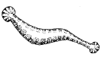 | 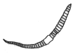 | 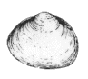 | 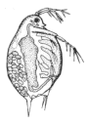
Leech | Water worm | Pea-shell Cockle | Water Flea
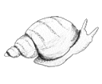 | 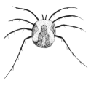 | 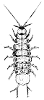 | 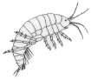
Pond Snail | Water Mite | Water Louse | Freshwater Shrimp

