Acid Deposition

Acid deposition was a major environmental problem in the 1970s and 1980s and continues to be a problem as long as fossil fuels are burned. This is one of the reasons why it is still a large part of the pollution problems facing China. Fossil fuels were originally living creatures; Oil was marine organisms such as plankton, and coal were the vast carboniferous forests. This means that oil and coal contain compounds containing sulphur and nitrogen, compounds that are essential in living organisms. When coal and oil are burned these compounds are oxidised and form various sulphur and nitrous oxides which enter the atmosphere. These are primary pollutants, but it is their reaction with water to become the acids of sulphuric acid and nitric acid (secondary pollutants) which leads to acid deposition (which includes acid rain).

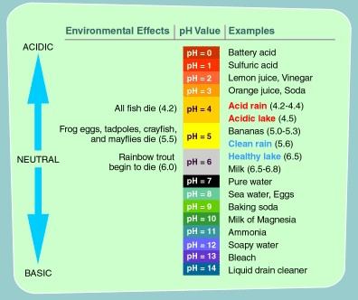
What Does Acid Mean?

The pH scale is a non-linear scale (negative logarithmic scale) of the concentration of hydrogen ions in a solution. For each decreasing point on the pH scale there are ten times more hydrogen ions in the solution. The pH scale runs from 0 – 14 with 0 being the strongest acid, 7 being neutral and 14 being most basic (alkaline).
Rain water is normally a weak acid as the carbon dioxide in the atmosphere dissolves in the rain creating a weak solution of carbonic acid. This is not considered to be acid rain even with increasing amounts of carbon dioxide in the atmosphere although there is increasing evidence of the dangers of ocean acidification. Nitrogen in the atmosphere becomes oxidised by the action of lightning and can then dissolve in rain to form nitric acid. This is an important source of nitrogen for plants. Certain pollutants can dissolve in this rain water causing pH readings below pH 2.4.
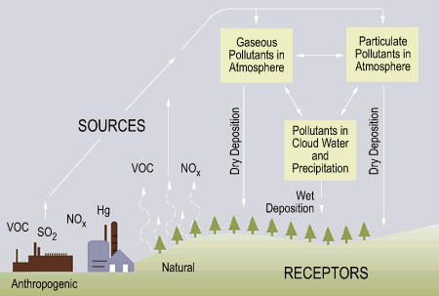
How does Acid Deposition Form?
The main primary pollutants leading to acid rain are sulphur dioxide (SO₂) and nitrous oxides (NO, NO₂, NO_{x}). The origin of these is the burning of fossil fuels in transportation, industry and electricity generating plants. Any fossil fuel will contain both sulphur and nitrogen due to its origins as living organic matter. Nitrogen in the atmosphere is also oxidised by the high temperatures of combustion.
Ammonia from farming and the nitrates in inorganic fertiliser are also an important and possibly underestimated source of acid rain and contributors to global warming.
The primary air pollutants of SO₂ and NO_{x} both react with water in the atmosphere forming secondary pollutants.
Sulphur dioxide can react with oxygen to form sulphur trioxide. Both sulphur dioxide and sulphur trioxide (SO₃) react with water to form sulphurous acid (H₂SO₃) and sulphuric acid.
SO₂ + H₂O → H₂SO₄

Nitrogen oxides react with water to form nitric acid.
NO_{x} + H₂O → HNO₃

These secondary pollutants can be deposited as dry particles relatively close to their source (dry deposition) but when rain is available, they are very soluble and can fall as wet deposition.
Once in the atmosphere the pollutants can travel relatively long distances, across country boundaries, although they remain a regional rather than global problem. This pollution is moved by wind patterns and so the prevailing wind direction is important. For example, pollution formed in the United Kingdom was blown to Scandinavia and caused great problems there.

What are the Effects of Acid Deposition?

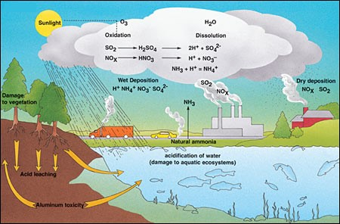
1) Soil Ecology
The effect that acidic rain has on soil depends upon the base rock (geology). If the base rock forming the soil is calcium carbonate, e.g. limestone, chalk and serpentine, then these soils tend to be alkaline and will buffer the acidic rain (neutralise the hydrogen ions). If the soils are derived from acidic rocks, e.g. granite and rhyolite, then there will be few available ions to neutralise the acidic rain and therefore acidic soil is very sensitive to acidic rain.
Acid rain reduces a soils ability to hold onto nutrients such as calcium, magnesium and potassium ions. These are leached out of the soil reducing the productivity of the soil. This is combined with the reduced effectiveness of symbiotic bacteria which further decreases the availability mineral ions for plants. This is classified as an INDIRECT NUTRIENT EFFECT.
Acidic rain increases the solubility of heavy metals and toxic aluminium ions, leaching them out of soil. These enter water courses and have an effect on aquatic organisms. This is classified as an INDIRECT TOXIC EFFECT.

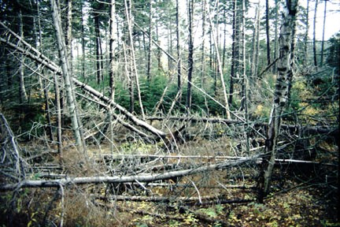
2) Forest Ecology
Acidic rain has caused dieback of trees in forests around the world including the Black Forest in southern Germany, forests across Sweden, central Europe, north-east USA, and north-east China. Both coniferous and deciduous can be affected. Leaves and buds can show yellowing (loss of chlorophyll) and damage in the form of lesions, thinning of wax cuticles and needle dropping in coniferous trees. This results in reduced growth and productivity. Trees become increasingly vulnerable to pathogens and low temperatures. This is classified as a DIRECT EFFECT.
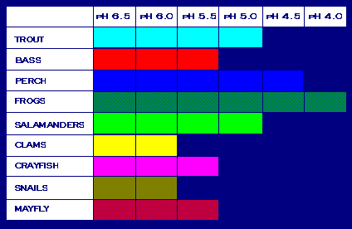
3) Fresh Water Ecology
Some aquatic organisms are very vulnerable to acidification of fresh water systems. Trout and Bass are sensitive to acidic water while shellfish are very sensitive, and frogs are much less sensitive. Most fish eggs won’t develop below pH 5. Some acidic lakes contain no fish. This is classified as a DIRECT EFFECT.
At low concentrations, the aluminium that is leached into water systems affects the ability of fish to regulate the amount of water and salts in their bodies. This can affect the intake of oxygen and salt; the fish slowly suffocating. It also causes chronic stress, reducing body weight and the ability to compete for food and habitat. At higher concentrations a solid is formed on the fish’s gills leading to suffocation. This is classified as an INDIRECT TOXIC EFFECT.

4) Lichen Ecology
Lichens are indicator species for air pollution, particularly sulphur dioxide. Very few species of lichen can tolerate heavy air pollution while some species are only found in the cleanest air. Lichen indicator species can be used to estimate the amount of air pollution and maps have been produced of air quality based on the distribution of lichens. This could be classified as a DIRECT EFFECT.

5) Effect on Buildings
Acid rain damages limestone buildings and statues causing their degradation; the acid reacts with the calcium carbonate releasing carbon dioxide. This can cause economic impacts as the cost of repair can be large.
Impacts of Acid Deposition Cross Country Boundaries

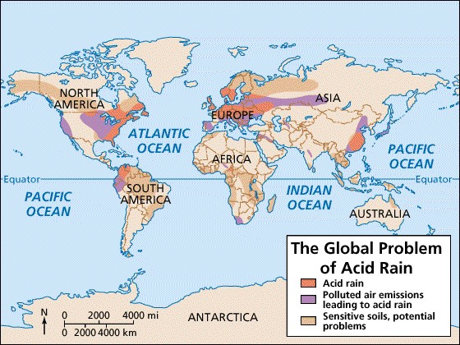
Acid deposition is considered to be a regional problem, but solutions are sometimes sought globally as the problem’s cross international boundaries.
It is not only industrialised areas which suffer from acid rain. The primary pollutants contributing to acid rain are produced in these industrialised areas but then winds blow these particles, sometimes thousands of kilometres away from the source. This leads to regional problems but not to global problems due to the distance travelled and the pollutants eventually being washed out of the air by precipitation.
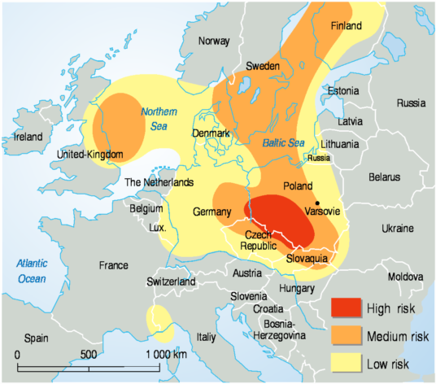
In Europe, Sweden has suffered from acidic rain originating in the north of England and Germany. The soils in Sweden are particularly vulnerable as they are largely of acidic nature. Globally, North East USA, Europe and Eastern China are particularly hit by acidic rain but there are many areas with acidic soils which could become vulnerable if emissions from fossil fuel combustion increase in these regions.

Pollution Management Strategies for Acid Deposition

1) Altering Human Activity
Strategy | Evaluation | EVS
Replace car transport with low emission transport such as bicycles, electric vehicles, alternative energy driven transportation. | Need to encourage bicycle use through sharing stations – requires public investment (low cost) and needs to be within easy reach.  Need charging stations – public investment in infrastructure – simply moves the source of pollution elsewhere unless electricity produced by renewable sources | Ecocentric / Technocentric
Car pooling | Reduces cars on road but requires people to change habits and organize time with others. | Ecocentric
Improving public transportation networks | Expensive but very effective. Some resistance may come from political beliefs against a social way of living. | Ecocentric / Technocentric.
Encouraging home-working to reduce transportation requirements. | May reduce peoples’ social contact causing depression. | Ecocentric

2) Controlling release of Pollutant
Strategy | Evaluation | EVS
Reduce the sulfur content of fossil fuels | Increases cost as low sulfur fuel more expensive and requires technological investment. Can be anthropocentric if government requires the sulphur content to be reduced. This has been the most successful way of reducing acid deposition in the US. | Technocentric / Anthropocentric
Use catalytic converters on car exhausts. | Very effective at reducing NOx but costs more and uses heavy metals which need to be mined. Scrubbers / CATS expensive to install and maintain. Catalysts need replacing frequently. | Technocentric
Removing sulfur from emissions using scrubbers which are fitted to chimneys of power generation plants. These spray limestone powder into the chimney which reduces the sulfur content of the emissions. Water then washes this out of the chimney and the product is collected.  The calcium carbonate of the limestone produces pH neutral calcium sulfate that is physically removed from the scrubber. | Effective but requires investment in the technology though not particularly high-tech.  Desulfurisation of coal is costly. | Technocentric / Anthropocentric as usually mandated by government
Switch to use of renewable energy sources. | Requires diversification of energy supply in order to ensure constant supply. Requires massive investment in infrastructure and political will to do this.  Many alternative sources have disadvantages e.g. aesthetic aspects of solar/wind generation.  Problems of disposing of nuclear waste.  Many governments dependent on tax revenue from extraction/use of fuels; especially in LEDCs with rapidly rising populations/aspirations.  Many alternatives are costly and require advanced technology.  Production of solar panels may involve some pollution – e.g. heavy metals needed. | Technocentric when thinking about the changes in technology and future carbon zero economy.  Anthropocentric when governments require the switch.  Ecocentric when individuals make the choice to change their source of energy, e.g. installing solar panels on the roof.
Increasing efficiency of power production and vehicles. | Can be encouraged through legislation. Could reduce costs for consumer in long run but investment in more energy efficient technology may be required.  Has advantage of reducing emissions of all pollutants produced by burning fossil fuels. | Technocentric and Anthropocentric
Use acid resistant building materials instead of limestone | Alternative building materials may have other environmental costs and it is costly to replace old buildings | Technocentric
Congestion charges – a tax on driving into the city, e.g. London | Very effective but requires political will and requires improved public transport as an alternative. | Anthropocentric
Tax personal transportation, e.g. fuel tax, car tax, parking charges. | Very effective but requires political will and requires improved public transport as an alternative. | Anthropocentric
Encourage carbon trading (carbon credits). | Can be successful and still widely encouraged by economists but schemes have failed when the price placed on carbon is not correct or if too many permits are awarded. | Anthropocentric
Alternate days when cars allowed to be used. | Has proved very successful when used in Paris, Delhi and Beijing but often used when emergency measures are required due to very bad air pollution. | Anthropocentric
Pollution trading credits – allocate permits to pollute which encourages a market approach to pollution management. | Has been shown to be effective in US with sulphur dioxide emissions.  Some would argue that it is ethically unsound to encourage pollution through permissions. | Anthropocentric
National legislation to reduce sulphur dioxide and nitrogen oxides production.  International legislation to control and reduces sulphur dioxide (Sulphur Emissions Reduction Protocol and Convention on Long Range Transboundary Air Pollution) | Both of these measures have proved successful although concentration on sulphur dioxide emissions has led to an increase in nitrous oxide production.  Can be difficult to implement international/regional agreements.

3) Clean-Up and Restoration of Damaged Systems
Strategy | Evaluation | EVS
Adding limestone powder to acid lakes neutralises the acid present and increases the pH of the water. | Effective and cheap solution to restoring fresh water ecosystems but does not remove the cause of the problem and therefore needs to be repeated. There is an environmental impact from the quarrying of the limestone. | Technocentric
Restocking of lakes after remediation. | Needs careful management and unlikely to restore the same ecosystem that existed prior to the pollution event due to the nature of complex systems and alternate stable state theory. | Technocentric

Checking Understanding:
1. Outline how acid deposition forms.
2. Identify the main source of the primary pollutants responsible for acid rain.
3. Outline the effects of acid deposition on soil, water, and living organisms.
4. Explain why acid rain can often affect areas at a distance from the source of the pollutants and discuss why that can make it an issue in managing the pollutant.
5. Outline and evaluate pollution management strategies for acid deposition. Be sure to include strategies at all levels, altering human activities, reducing and regulating at the source, clean up and restoration.
Test yourself...
1. Explain how acid deposition is formed.
2. What is the difference between wet and dry deposition?
3. Describe a direct effect, and indirect toxic effect and an indirect nutrient effect of acid deposition on ecosystems?
4. Describe how acid deposition can impact the built environment.
5. State an area that is recovering from the impacts of acid deposition and an area that is currently being impacted.
6. Describe how acid deposition can be thought of as a regional problem rather than a global problem.
7. Outline an example of when acid deposition causes cross-boundary problems.
8. Evaluate five different strategies for dealing with acid deposition. Include strategies from each level of the pollution management model (Human Activity, Controlling Release, Impact).

